**Veer Narmad South Gujarat University, Surat.**

**Department of Information and Communication Technology**

**Project Report**

**2nd Semester**

# **M.Sc. (Information and Communication Technology)**

**2 Year Course**

**Year 2021– 2022**

# **“DS Online Food Ordering System”**

Guided By: Submitted By:

**Dr. Parul Patel** **Katrodiya Dhruvi P.(8634)**

**Maniya Shilpa P.(8640)**

**Veer Narmad South Gujarat University, Surat.**

**Department of Information and Communication Technology**

**M.Sc. (Information and Communication Technology)**

**Programme**

**Certificate**

This is to certify that Miss. **Katrodiya Dhruvi P.** with Exam Seat Number: **8634** and Enrollment Number: **R21110018000710014** has worked on his/her part time project work entitled **DS Online Food Ordering System** as a partial fulfillment of the requirements for **2nd Semester - M.Sc. (Information and Communication Technology)**, during the academic Year 2021-2022.

Date :

Place : Dept. of ICT, VNSGU, Surat.

**Internal Project Guide Course Coordinator Head of the Department**

**M.Sc.(I.C.T.) 2 nd Semester M.Sc. (I.C.T.) Programme Department of I.C.T.**

**Department of I.C.T. Department of I.C.T. Veer Narmad South Gujarat**

**Veer Narmad South Gujarat Veer Narmad South Gujarat University, Surat**

**University, Surat University, Surat**

Acknowledgement

Success in such a comprehensive project cannot be achieved single-handled. It is team effort that sails the ship to the coast. So, we would like to express our sincere thanks to all the dignitaries who were involved in making this project a great joy and turning it into successful piece of work.

We would like to take opportunity to thank our college J.P. Dawer Institute of Information Science & Technology, Surat for giving us this tremendous opportunity to work in the realtime project.

Dr. Parul Patel, our project coordinator, has been very prudent to us throughout our college studies. She is the person who has been giving direction to our work and the shape to our imagination. We express our regards to her from the core of our heart.

we also like to thank to Dr. Dhaval Joshi Sir who are always ready to give best guidance, give solutions whenever required.

We would also like to acknowledge all our friends and colleagues, team members for their help and encouragement from time to time. The constant support and encouragement of our friends deeply appreciate. The project indeed gave challenging and exhilarating experience in designing and developing the required system.

Finally, we would like to thank our Parents for their support throughout the project. We owe a special debt to our family & friends for their supports blessing and encouragement for me.

Regards,

Katrodiya Dhruvi P.(8634)

Maniya Shilpa P.(8640)

### INDEX

|  |  |  |
| --- | --- | --- |
| Sr. No | Topics | Page no. |
| 1. | Introduction   1. Customer Profile    1. Current System – about the existing system (manual or s/w)    2. Customer Detail | 5 |
| 2. | Proposed System   2.1 Scope               2.2 Objective               2.3 Advantages               2.4 Limitation | 7 |
| 3. | Environment Specification               3.1 Hardware & Software Requirements               3.2 Development Description | 9 |
| 4. | System Planning               4.1 Feasibility Study               4.2 Software Engineering Model               4.3 Risk Analysis               4.4 Project Schedule                    4.4.1 Task Dependency                    4.4.2 Timeline Chart | 10 |
| 5. | System Analysis               5.1 Detailed SRS               5.2 UML Diagram                     5.2.1 Use Case Diagram                     5.2.2 Class Diagram                     5.2.3 Activity Diagram                     5.2.4 Sequence Diagram              5.3 E-R Diagram | 14 |
| 6. | Software Design               6.1 Database Design               6.2 Interface Design sitemap followed with page snapshots               6.3 Architecture Design | 27 |
| 7. | Testing  7.1 Unit Testing  7.2 Integration Testing | 55 |
| 8. | Future Enhancement | 58 |
| 9. | Reference | 59 |

# 1. Introduction

**1. Customer Profile :**

* 1. **Current System – about the existing system (manual or s/w)**

## Existing System

* The current system is totally manual.
* Maintain all data records in on paper.
* Due to manually process, it requires more time for completion of any work.
* Lots of time consumed to the requires is difficult and time consuming.
* Manual system is takes more time to compete any task.
* This system require more human resource to run the system.
* Require infrastructure to operate the system
* People need to come at shop for order food.
* View past reports task is very tadius.

## Current System

* This System required less time for processing.
* Reduce paper work and paper cost.
* Reduce the infrastructure cost.
* Easily generate and maintain the reports
* Various details have to be providing to the management at any time.
* Better Security.
* The System require less human resource.

**1.2 Customer Detail**

* **Project Title :** DS Online Food Ordering System
* **Objective :** An online food ordering system can be defined as software that allows restaurant businesses to accept and manage orders placed over the internet. Online ordering systems generally consists of 2 main components. First is a website or mobile app for hungry customers to view the restaurant's dishes and place an online order. Second is an admin management interface for the restaurants to receive and manage the customer's orders.
* **Front End Tools :** Asp.net(C#, MVC)
* **Back End Tools :** Microsoft SQL Server Management Studio 2018
* **Other Tools :** HTML5, CSS and BOOTSTRAP4
* **Institute :** J.P Dawer Institute of Information Science

And Technology, VNSGU, Surat.

* **Time Duration :** 2 Months
* **Guided By :** Dr. Parul Patel

1. **Proposed System**

**2.1 Scope**

* Scope in Online Food Ordering System This project aimed at developing an online food ordering system which can be used in small places, and medium cities firstly and then on a large scale. It is developed to help restaurants to simplify their daily operational and managerial task as well as improve the dining experience of customers.
* And also helps restaurant develop healthy customer relationships by providing good services.
* The system enables staff to let update and make changes to their food and beverage list information based on the orders placed and the orders completed.

**2.2 Objective**

The general objectives of the study is to develop a reliable, convenient and accurate Ordering System.

The study has the following specific objectives:

* To develop a system that will surely satisfied the customer service.
* To design a system able to accommodate huge amount of orders at a time.
* To evaluate its performance and acceptability in terms of security, user-friendliness, accuracy and reliability.
* To improve the communication between the client and the server and minimize the time of ordering.

 One of the main objectives of a restaurant to ensure customer satisfaction.

* To automatically compute the bill.

         The system will also automatically calculate and displays the final bill so the bills will ready to print without having any error because the information for that item is already inserted.

**2.3 Advantages**

Running an online food ordering system adds flexibility to the business, which will ultimately increase sales and profits.

Easier ordering process – People love to boss around there orders. When the companies are introducing apps or website for there business on the internet, no more need for human interaction with the customer. People can choose and customize accordingly.

-Easy, fast, and comfortable

-Higher customer spend:

-Increased customer loyalty:

-Safer and healthier

-1. Makes the ordering process easier

Traditionally, people had to make calls to place orders or drive to the restaurants for a take-out, then wait for the food to be prepared and delivered. Sometimes, placing an order on the phone means that there could be mistakes in order. Clearly, these aren't really the best solutions to order food from restaurants especially for people with busy lifestyles.

The best solution is switching over to online ordering

2.. Efficient customer and order management

An online ordering system for Restaurants helps enhance the customer-restaurant relationship by providing end to end Customer Relationship Management (CRM) system.

**2.4 Limitation – things that are not there, but could be achieved**

While there are many advantages to the online food ordering system, there are also some disadvantages to online food ordering systems. They are

* price
* Limited menu
* Quality of food may be suffer
* Food may get cold

**3. Environment Specification**

**3.1 Hardware & Software Requirements**

The efficient hardware and software configuration required to run the system is as suggested below . The configuration suggested is adequate same functionality or higher configuration wills always be better.

|  |  |
| --- | --- |
| Type | Description |
| RAM | 8 GB |
| Microprocessor | Intel Core Processor i3 |
| Operating System | Microsoft Windows 10 |
| Browser | Google Chrome, Mozilla Firefox, Internet Explorer |
| Front End | ASP.NET(C# , MVC) |
| Back End | Microsoft SQL Server 2018 |
| Software | Microsoft Visual Studio 2022, SQL Server 2018 |

**3.2 Development Description**

Systems development is the process of defining, designing, testing, and implementing a new software application or program. It could include the internal development of customized systems. In online food system there are three modules first is Admin , Second is User or Customer, Third is Restaurant. Admin is a responsible person who operate the whole system. Admin has rights to add, delete, modify category , item and all other information regarding to online food ordering system.

**4. System Planning**

**4.1 Feasibility Study**

The measure of how beneficial or practical the development of informant system will be to an organization . Along this topic feasibility is measured . So far taking the feasibility study and feasibility analysis during the development of the project Online Food Ordering System we have studied on the following four major categories of feasibility study .

4.1.1 **Operational Feasibility** Operational feasibility is the measure of how well the project will support the customer and the service provider during the operational phase . It answers the question , " Is the project feasible to operate or not ? "

4.1.2 **Technical Feasibility** It measures the feasibility of the particular technical solution and the availability of technical resource and expertise . Technical feasibility looks at what is practical and reasonable . It mainly addresses their major issues .

* Is the proposed technology or solution practical ?
* Do we currently possess the necessary technology and technical expertise ?

4.1.3 **Schedule Feasibility** It is the measure of how reasonable the project time table is or the deadline is reasonable or not . During the lack of time or the time become mandatory , we must finish the project within a given time period . It mainly addresses

* Can the project really be completed in the given period of time ?

4.1.4 **Economic Feasibility** It is the measure of the cost - effectiveness of a project , which is often called cost - benefit analysis . As long as the end - users requirements and alternative technical solution have been identified , we can identify the raw cost weight and benefit of each alternative .

During the development of Online Food Ordering System , we have tried to address all these feasibility analysis phases seriously . That's why we think , our project will succeed properly .

**4.2 Software Engineering Model**

Waterfall approach was first SDLC Model to be used widely in Software Engineering to ensure success of the project. In "The Waterfall" approach, the whole process of software development is divided into separate phases. In this Waterfall model, typically, the outcome of one phase acts as the input for the next phase sequentially.

The following illustrate

on is a representation of the different phases of the Waterfall Model.

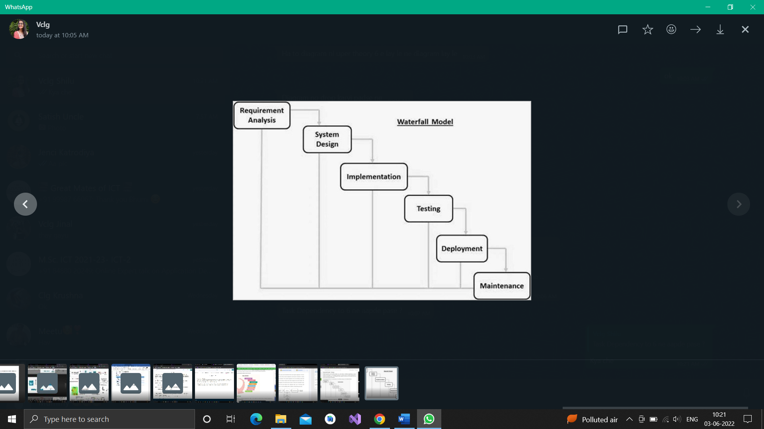

**4.3 Risk Analysis**

Risk Analysis is very essential for software testing. In software testing, risk analysis is the process of identifying risks in applications and prioritizing them to test. A risk is a potential for loss or damage to an organization from materialized threats. Risk Analysis attempts to identify all the risks and then quantify the severity of the risks. A threat as we have seen is a possible damaging event. If it occurs, it exploits vulnerability in the security of a computer based system.

**4.4 Project Schedule**

**4.4.1 Task Dependency**

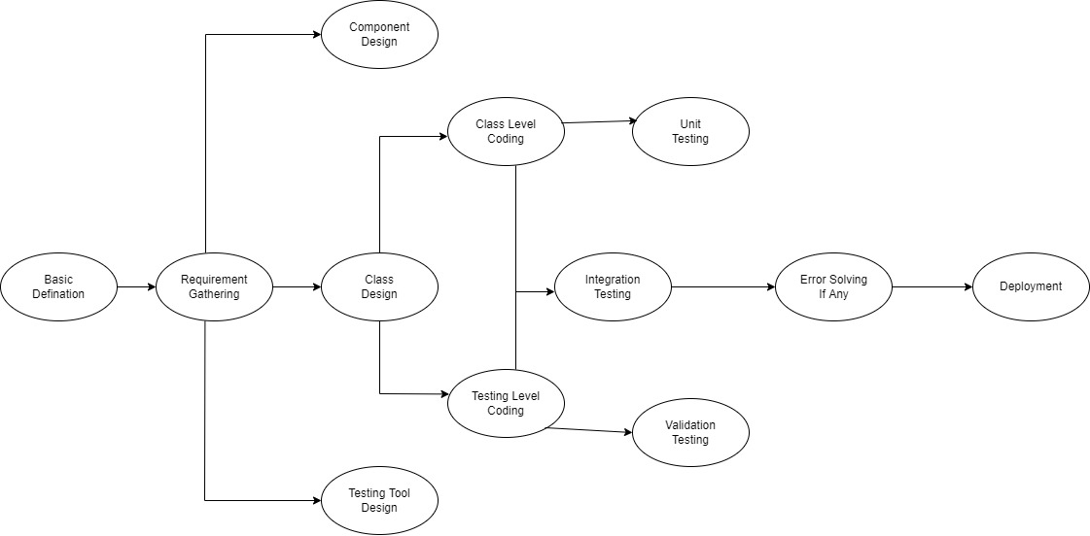

**4.4.2 Timeline Chart**

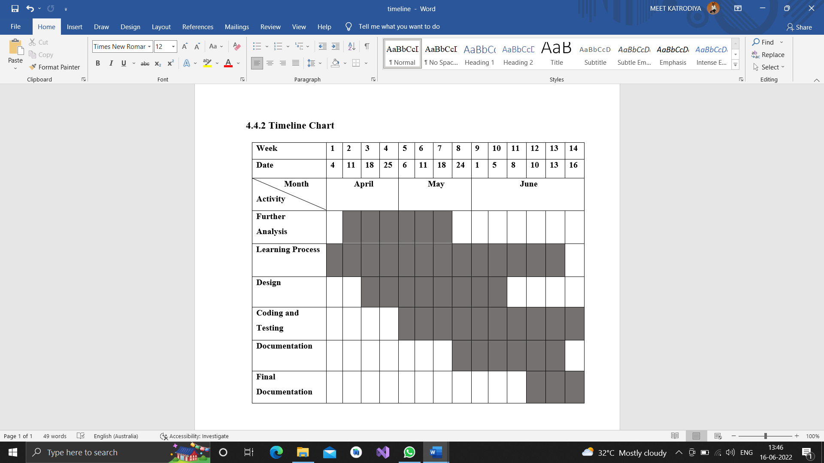

**5. System Analysis**

**5.1 Detailed SRS**

Actors :-

* Admin
* Restaurant
* Customer
* Visitor
* Admin Panel (Functionality) :-
* The admin will add, upgrade, remove ,search and view the restaurant
* Admin can add ,update ,delete , view city and state
* Admin can add ,update ,remove ,view and search in Category (Like :- Italian, Gujarati, Chinese, etc.…)
* View all the customers
* Admin can view Customer Feedback
* Admin can view date wise selling report
* Restaurant Panel (Functionality) :-
* The restaurant will be able to operate after the admin add the restaurant
* Restaurant can view the order
* Add, update ,remove food item from the menu
* Update price for a given food item
* Update additional information (description , image, etc.) for a given food item
* The restaurant will be able to see the customer who made the payment
* View all the customers
* Can see which customer’s order status
* Manage order status (pending, cancelled, completed, processing, ongoing)
* View all reviews given by customer’s
* Restaurant can view date wise selling report
* Customer (Functionality) :-
* Login into the system
* View all the restaurants
* View all the category wise menu
* Add a review in menu item
* Add a feedback in system
* Will select the restaurant of his choice
* Select one or multiple item from the menu list
* Select the item you want to add to the cart
* Then order the selected item
* Give a payment for particular order
* View the order status
* Receive an invoice

**5.2 UML Diagram**

**5.2.1 Use Case Diagram**

Admin Side

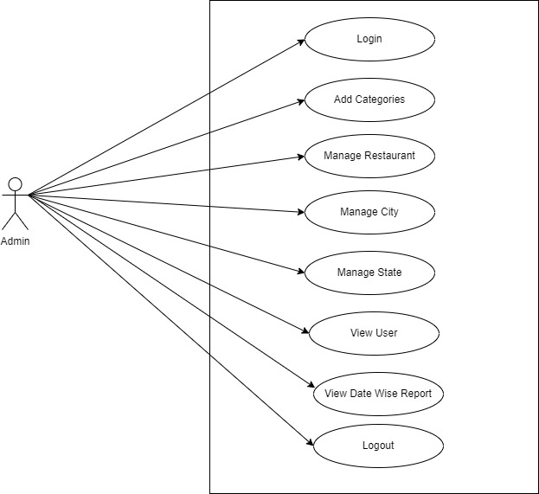

Restaurant Side

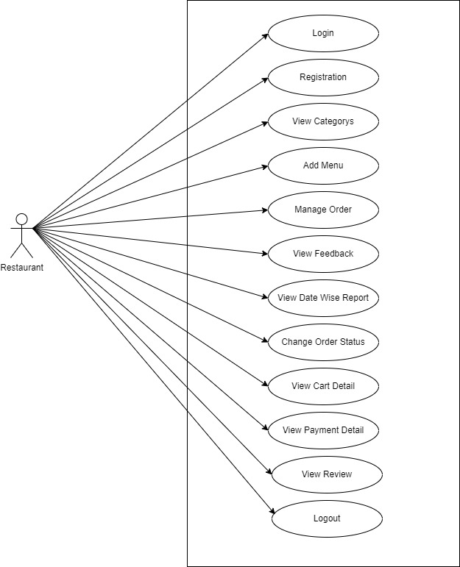

Customer Side

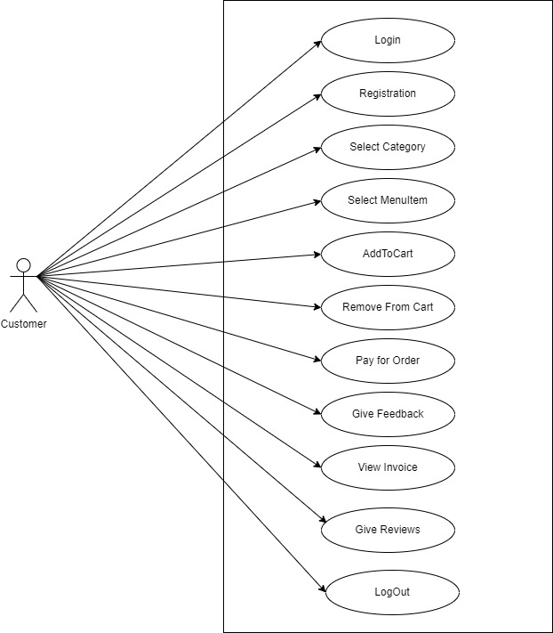

**5.2.2 Class Diagram**

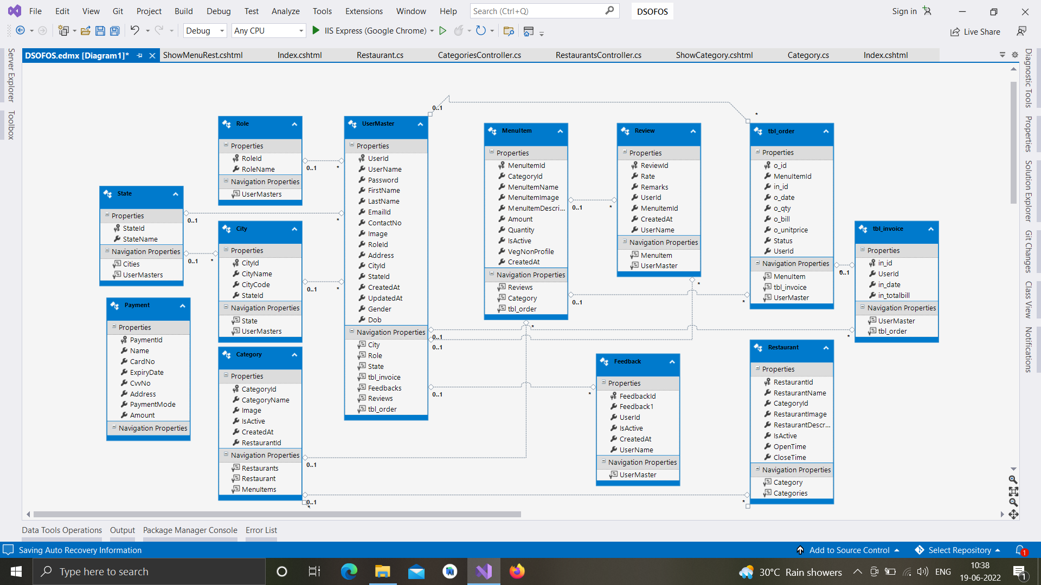

**5.2.3 Activity Diagram**

Admin

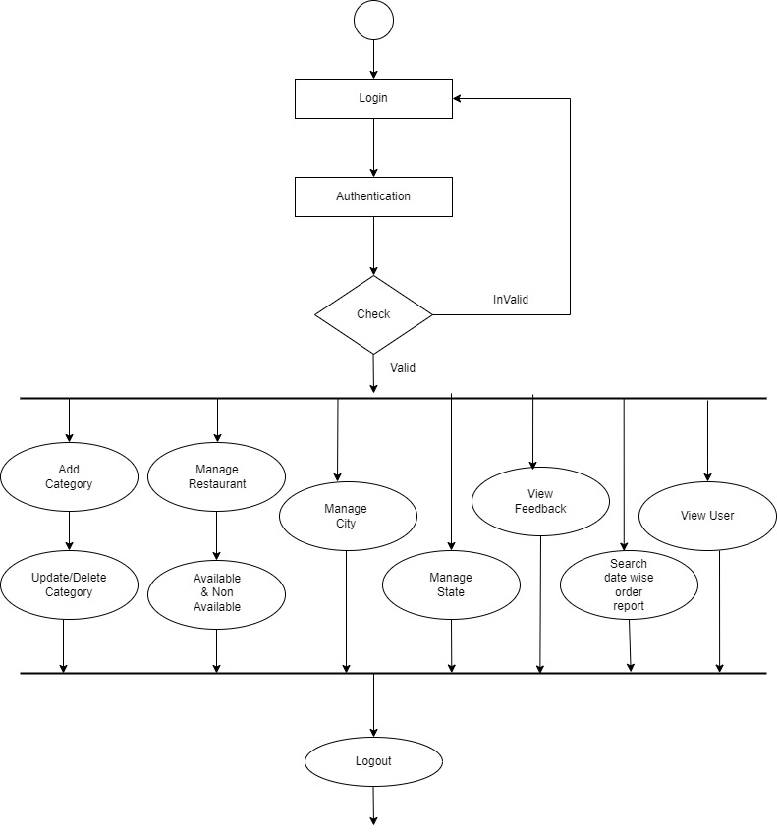

Restaurant

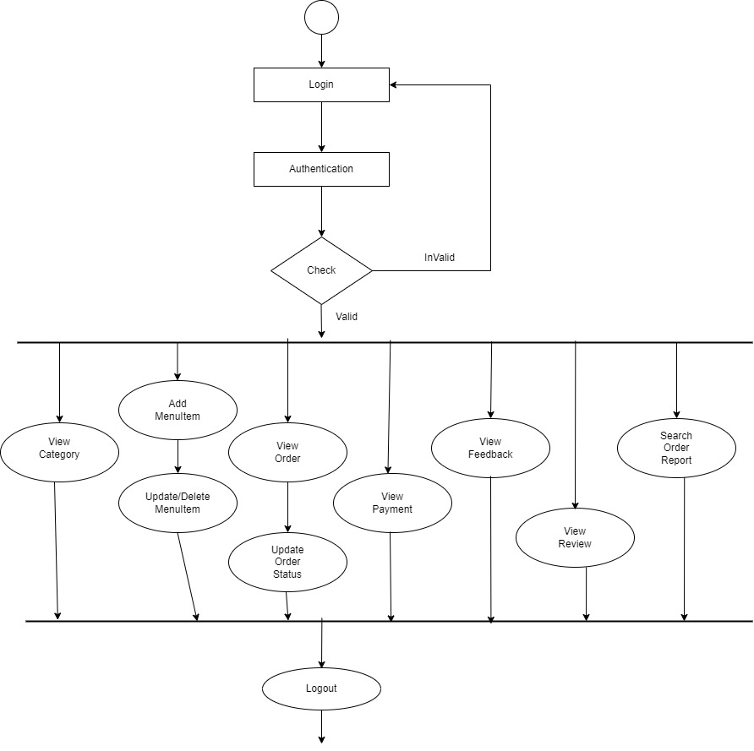

Customer

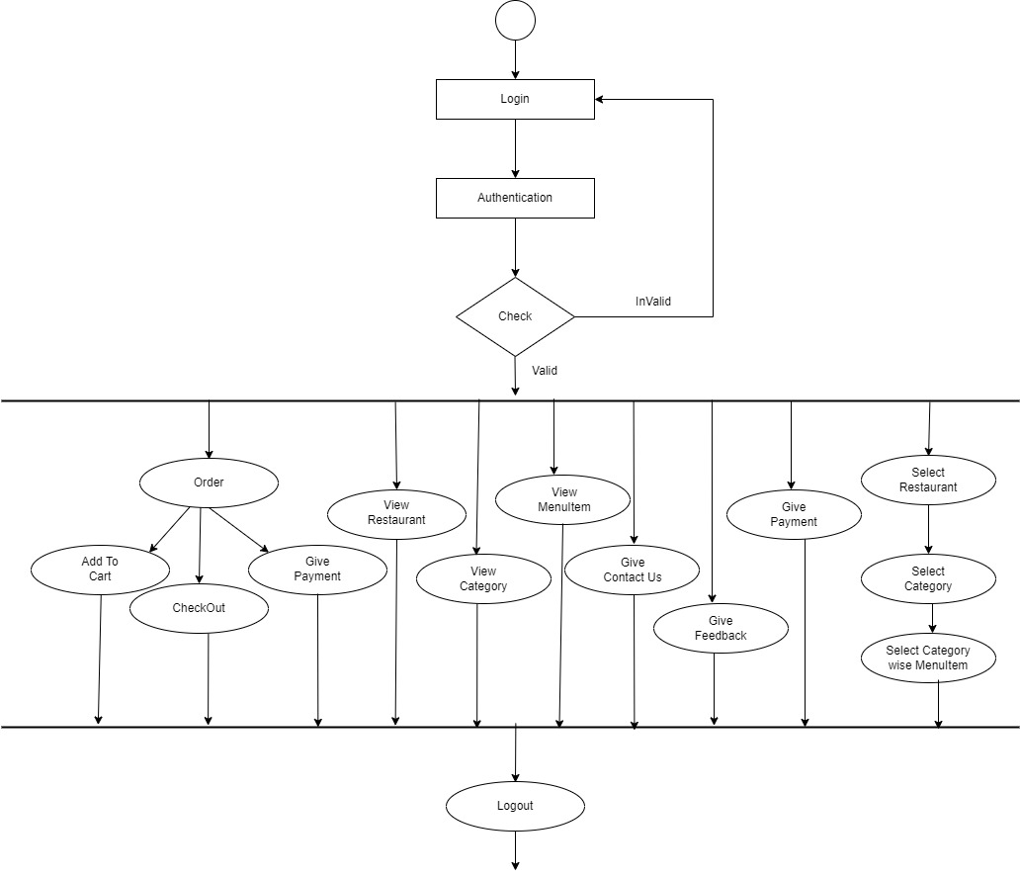

**5.2.4 Sequence Diagram**

Admin

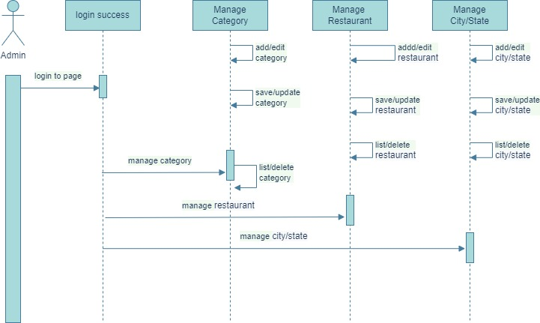

Restaurant

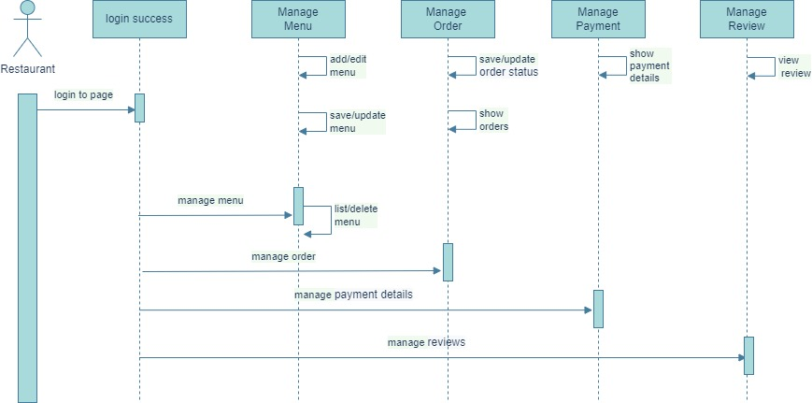

Customer

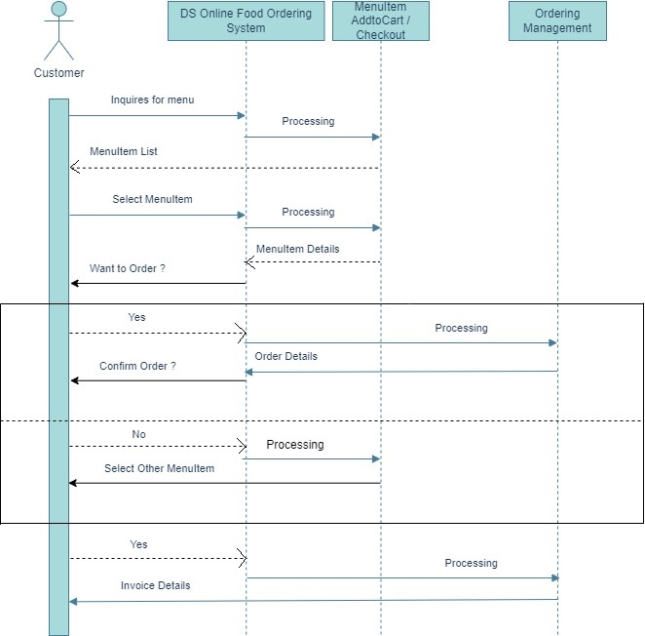

 5.3 E-R Diagram

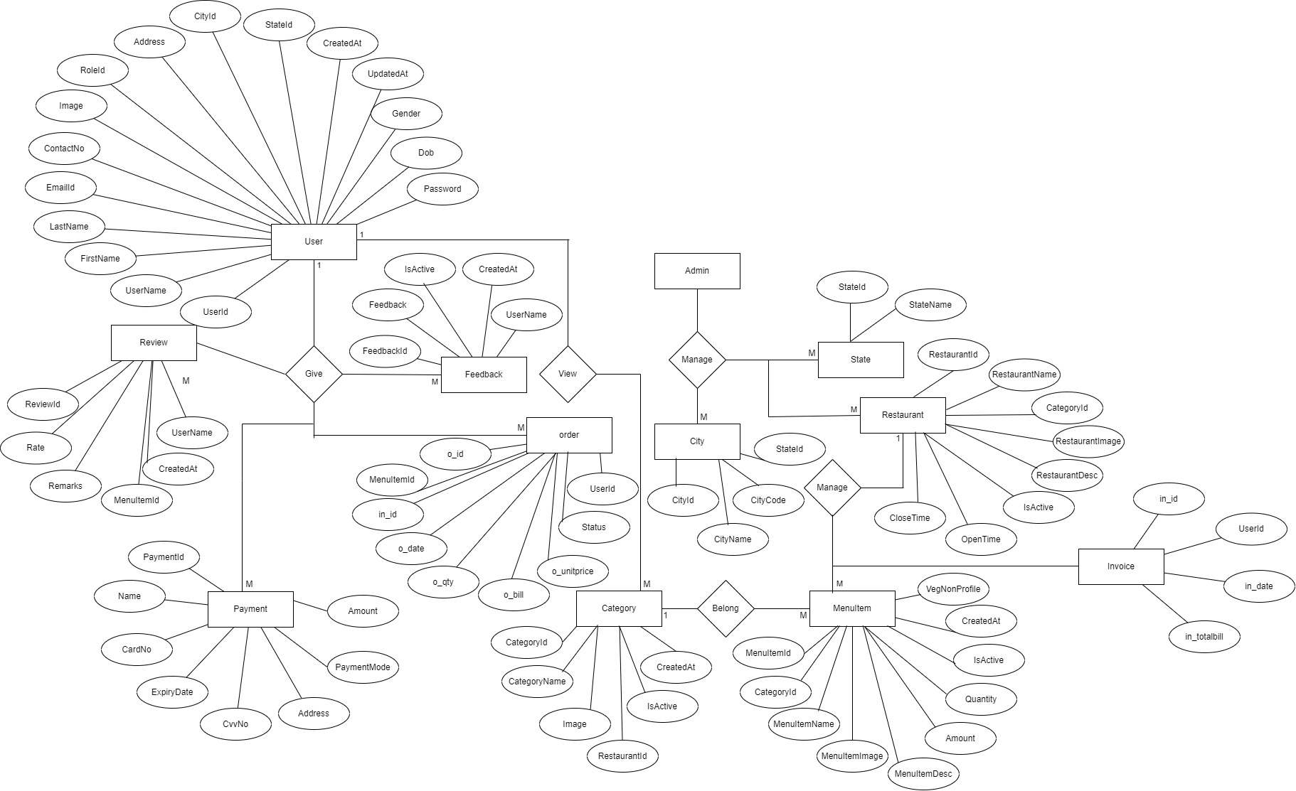

**6. Software Design**

**6.1 Database Design**

**1. Table : Category**

Primary Key : CategoryId

|  |  |  |  |
| --- | --- | --- | --- |
| Field Name | Description | Type | Required |
| CategoryId | Category Id | Int | Yes |
| CategoryName | Category Name | varchar | Yes |
| Image | Category Image | varchar(MAX) | Yes |
| IsActive | Category Active | bit | Yes |
| CreatedAt | Category Create Date | datetime | Yes |

1. **Table : City**

Primary Key : CityId

Foreign Key : StateId

|  |  |  |  |
| --- | --- | --- | --- |
| Field Name | Description | Type | Required |
| CityId | City Id | Int | Yes |
| CityName | City Name | varchar | Yes |
| StateId | State Id | Int | Yes |
| CityCode | City Code | Int | Yes |

1. **Table : Feedback**

Primary Key : FeedbackId

|  |  |  |  |
| --- | --- | --- | --- |
| FieldName | Description | Type | Required |
| FeedbackId | Feedback Id | int | Yes |
| Feedback | Feedback Description | Varchar | Yes |
| UserName | UserName | Varchar | Yes |
| IsActive | Feedback IsActive | bit | Yes |
| CreatedAt | Feedback CreatedAt | datetime | Yes |

1. **Table : MenuItem**

Primary Key : MenuItemId

Foreign Key : CategoryId

|  |  |  |  |
| --- | --- | --- | --- |
| FieldName | Description | Type | Required |
| MenuItemId | MenuItem Id | Int | Yes |
| CategoryId | Category Id | Int | Yes |
| MenuItemName | MenuItem Name | varchar | Yes |
| MenuItemImage | MenuItem Image | varchar | Yes |
| MenuItemDescription | MenuItem Description | varchar | Yes |
| Amount | Category Amount | Int | Yes |
| Quantity | Category Quantity | Int | Yes |
| IsActive | Category IsActive | Bit | Yes |
| CreatedAt | CreatedAt | datetime | Yes |
| VegNonProfile | VegNonProfile | bit | Yes |

1. **Table : Order**

Primary Key : OrderID

Foreign Key : MenuItemId, in_id

|  |  |  |  |
| --- | --- | --- | --- |
| FieldName | Description | Type | Required |
| o_id | Order Id | int | Yes |
| in_id | Invoice Id | int | Yes |
| MenuItemId | MenuItem Id | int | Yes |
| Status | Status | varchar | Yes |
| o_qty | Order Quantity | int | Yes |
| o_bill | Order Bill | int | Yes |
| o_unitprice | Order Unitprice | int | Yes |
| o_date | Order Date | datetime | Yes |

1. **Table : Payment**

Primary Key : PaymentId

|  |  |  |  |
| --- | --- | --- | --- |
| FieldName | Description | Type | Required |
| PaymentId | Payment Id | Int | Yes |
| Name | User Name | Varchar | Yes |
| CardNo | Card Number | Int | Yes |
| ExpiryDate | Expiry Date | datetime | Yes |
| CvvNo | Card Cvv Number | Int | Yes |
| Address | Address | varchar | Yes |
| PaymentMode | Payment Mode | varchar | Yes |

1. **Table : Restaurant**

Primary Key : RestaurantId

Foreign Key : CategoryId

|  |  |  |  |
| --- | --- | --- | --- |
| FieldName | Description | Type | Required |
| RestaurantId | Restaurant Id | int | Yes |
| RestaurantName | Restaurant Name | varchar | Yes |
| CategoryId | Category Id | int | Yes |
| RestaurantImage | Restaurant Image | varchar | Yes |
| RestaurantDescription | Restaurant Description | varchar | Yes |
| IsActive | Restaurant IsActive | bit | Yes |
| OpenTime | Restaurant OpenTime | varchar | Yes |
| CloseTime | Restaurant CloseTime | varchar | Yes |

1. **Table : Review**

Primary Key : payment_detail_id

Foreign Key : MenuItemId

|  |  |  |  |
| --- | --- | --- | --- |
| FieldName | Description | Type | Required |
| ReviewId | Review Id | int | Yes |
| Rate | Rate | int | Yes |
| Remarks | Remarks | varchar | Yes |
| UserName | UserName | varchar | Yes |
| MenuItemId | MenuItem Id | int | Yes |
| CreatedAt | Created At | datetime | Yes |
| IsActive | IsActive | bit | Yes |

1. **Table : Roles**

Primary Key : RoleId

|  |  |  |  |
| --- | --- | --- | --- |
| FieldName | Description | Type | Required |
| RoleId | Role Id | int | Yes |
| RoleName | Role Name | varchar | Yes |

1. **Table : State**

Primary Key : StateId

|  |  |  |  |
| --- | --- | --- | --- |
| FieldName | Description | Type | Required |
| StateId | State Id | int | Yes |
| StateName | State Name | Varchar | Yes |

1. **Table : Invoice**

Primary Key : in_id

Foreign Key : UserId

|  |  |  |  |
| --- | --- | --- | --- |
| FieldName | Description | Type | Required |
| in_id | Invoice Id | int | Yes |
| UserId | User Id | varchar | Yes |
| in_date | Invoice Date | datetime | Yes |
| in_totalbill | Invoice total bill | Float | Yes |

1. **Table : UserMaster**

Primary Key : UserId

Foreign Key : CityId, StateId, RoleId

|  |  |  |  |
| --- | --- | --- | --- |
| FieldName | Description | Type | Required |
| UserId | User Id | int | Yes |
| UserName | User Name | varchar | Yes |
| FirstName | First Name | varchar | Yes |
| LastName | Last Name | varchar | Yes |
| Address | Address | varchar | Yes |
| ContactNo | User Phone number | int | Yes |
| Dob | User Date Of Birth | Date | No |
| Gender | Gender | varchar | Yes |
| Image | User Photo | varchar | Yes |
| EmailId | User Email | varchar | Yes |
| Password | Password | varchar | Yes |
| CityId | User City Id | varchar | Yes |
| StateId | User State Id | varchar | Yes |
| RoleId | RoleId | int | Yes |
| CreatedAt | CreatedAt | datetime | Yes |

**6.2 Interface Design sitemap followed with page snapshots**

**Home Page**

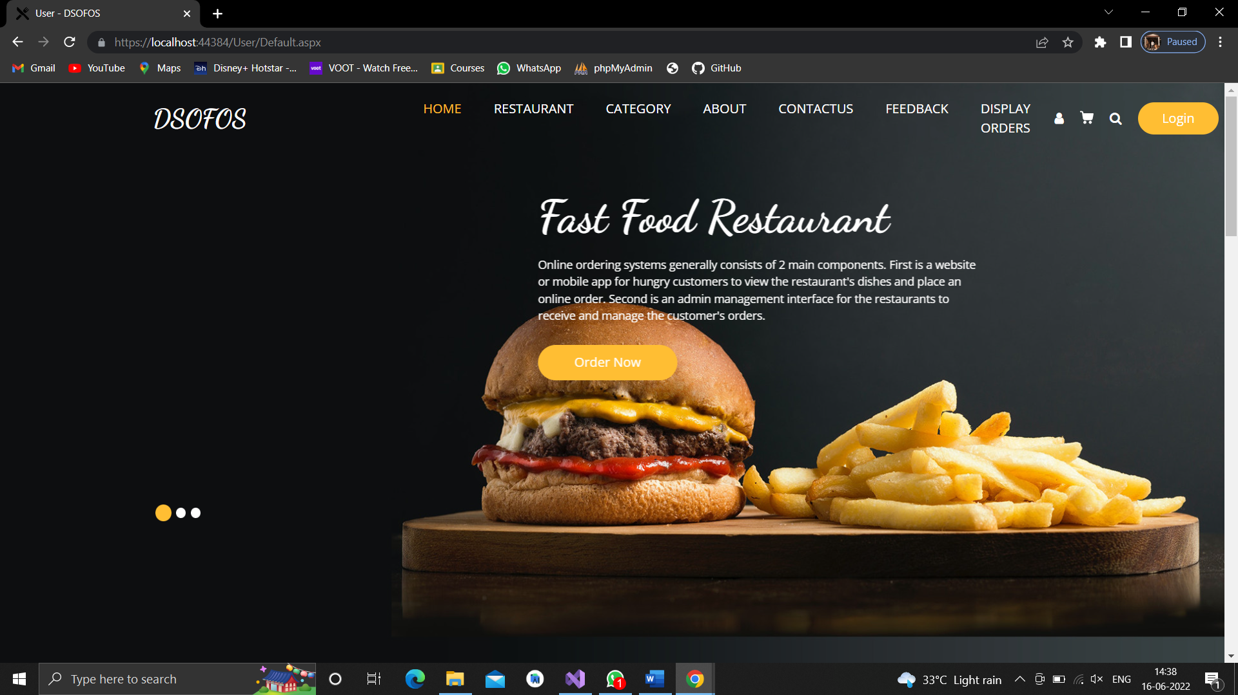

**About Us**

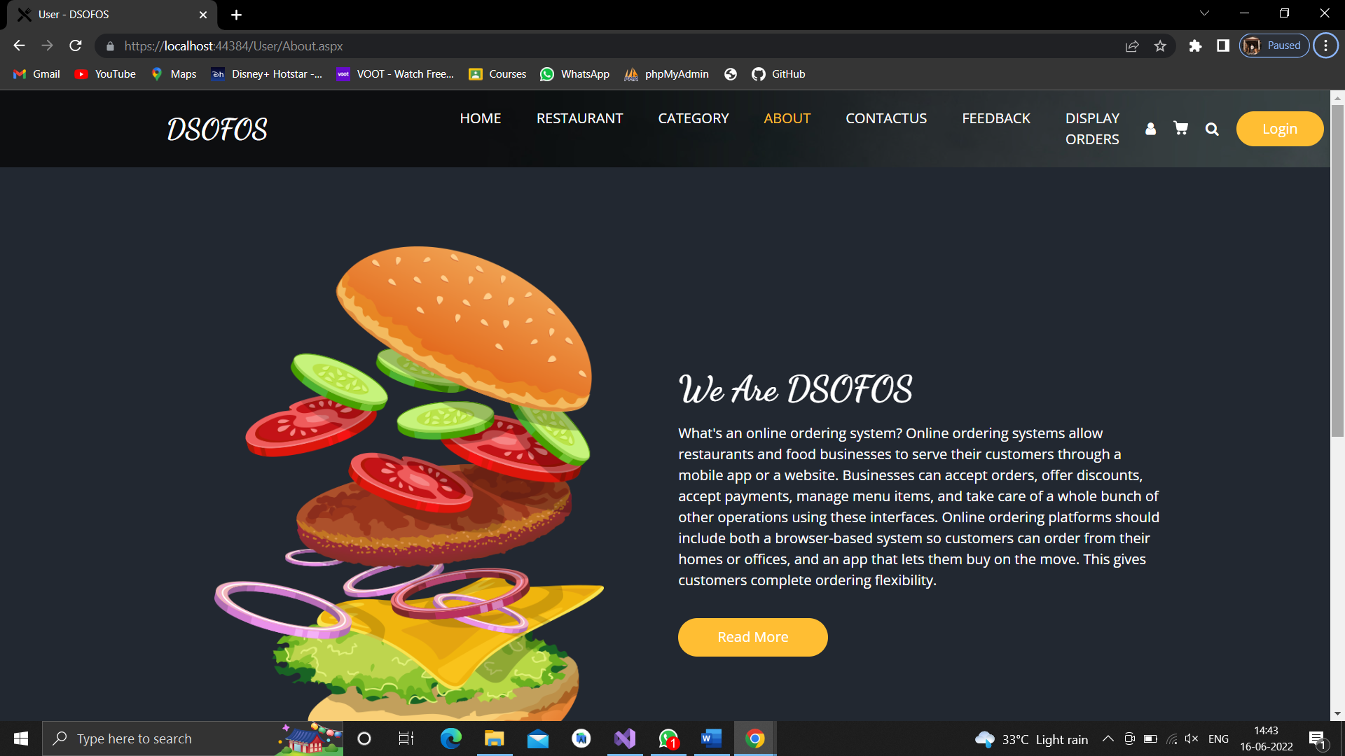

**Contact Us**

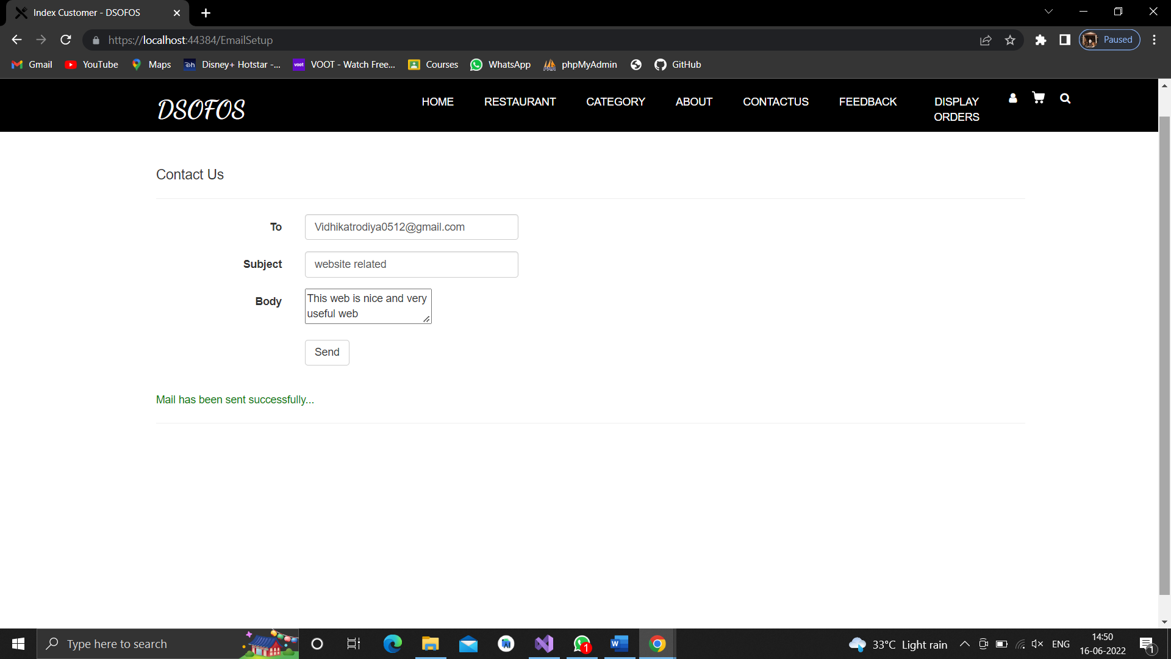

**Customer Login** 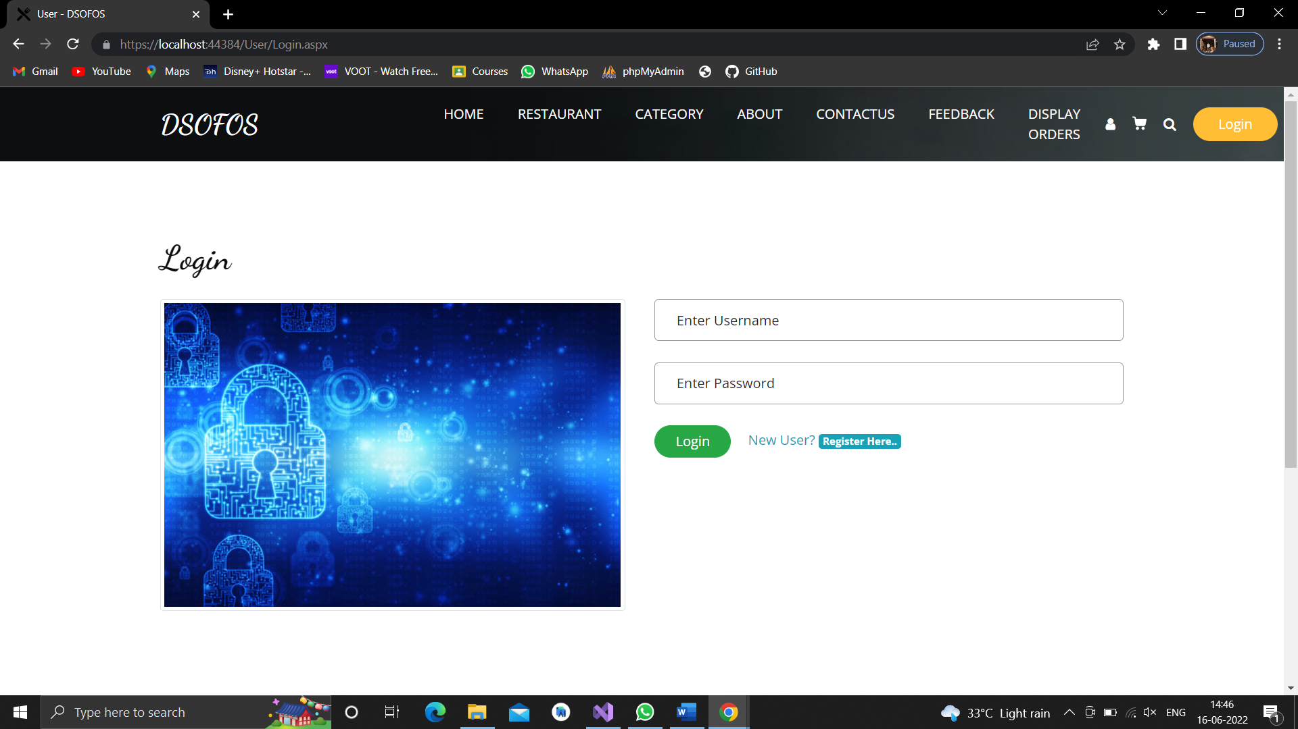

**Register Page**

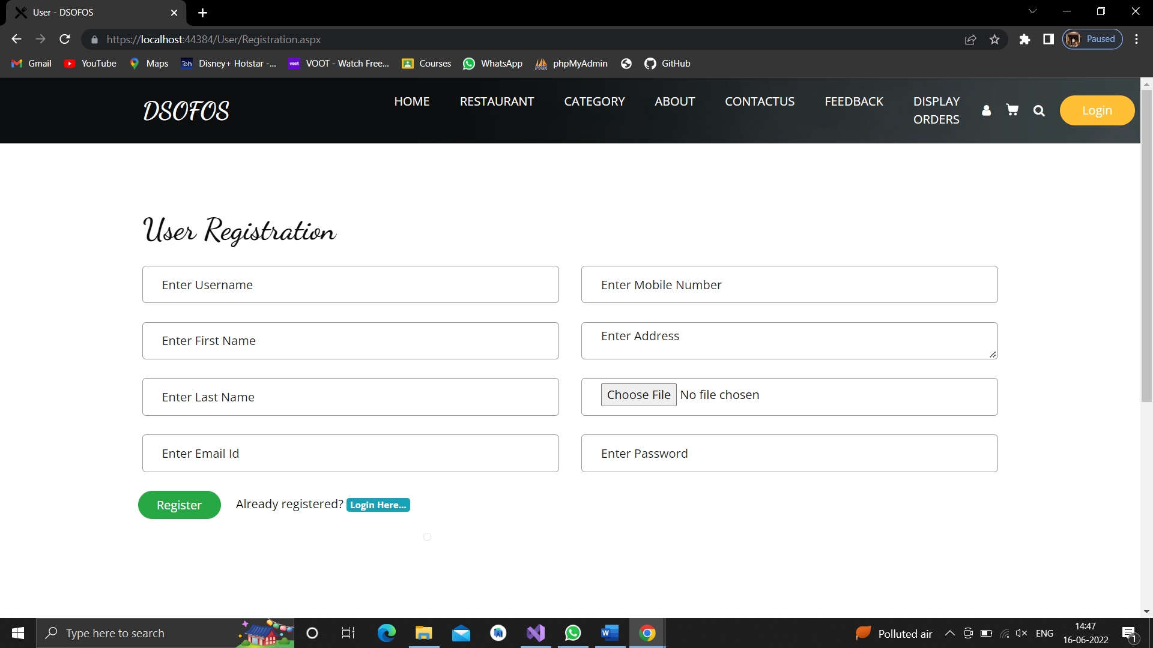

**Restaurants View**

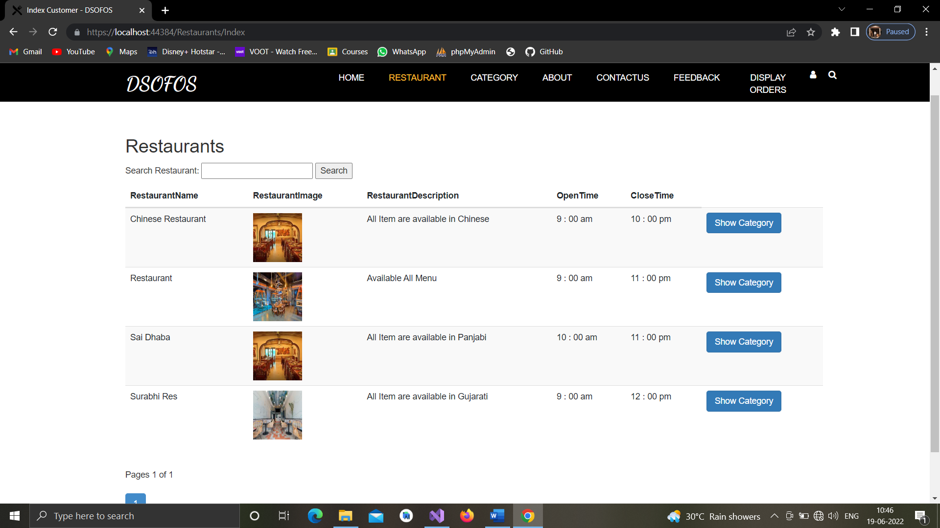

**Category View**

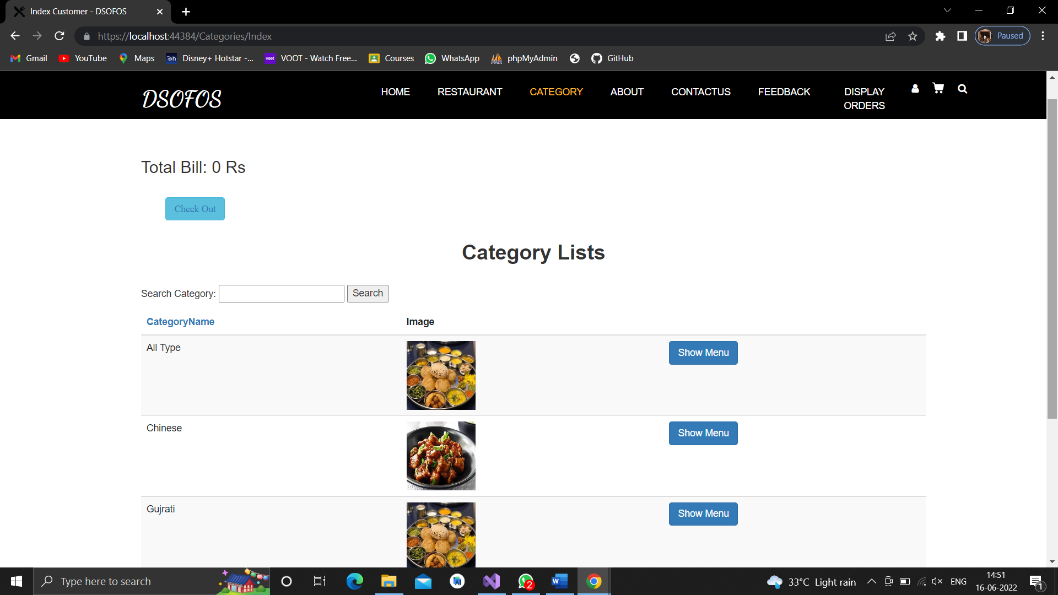

**Show MenuItem List**

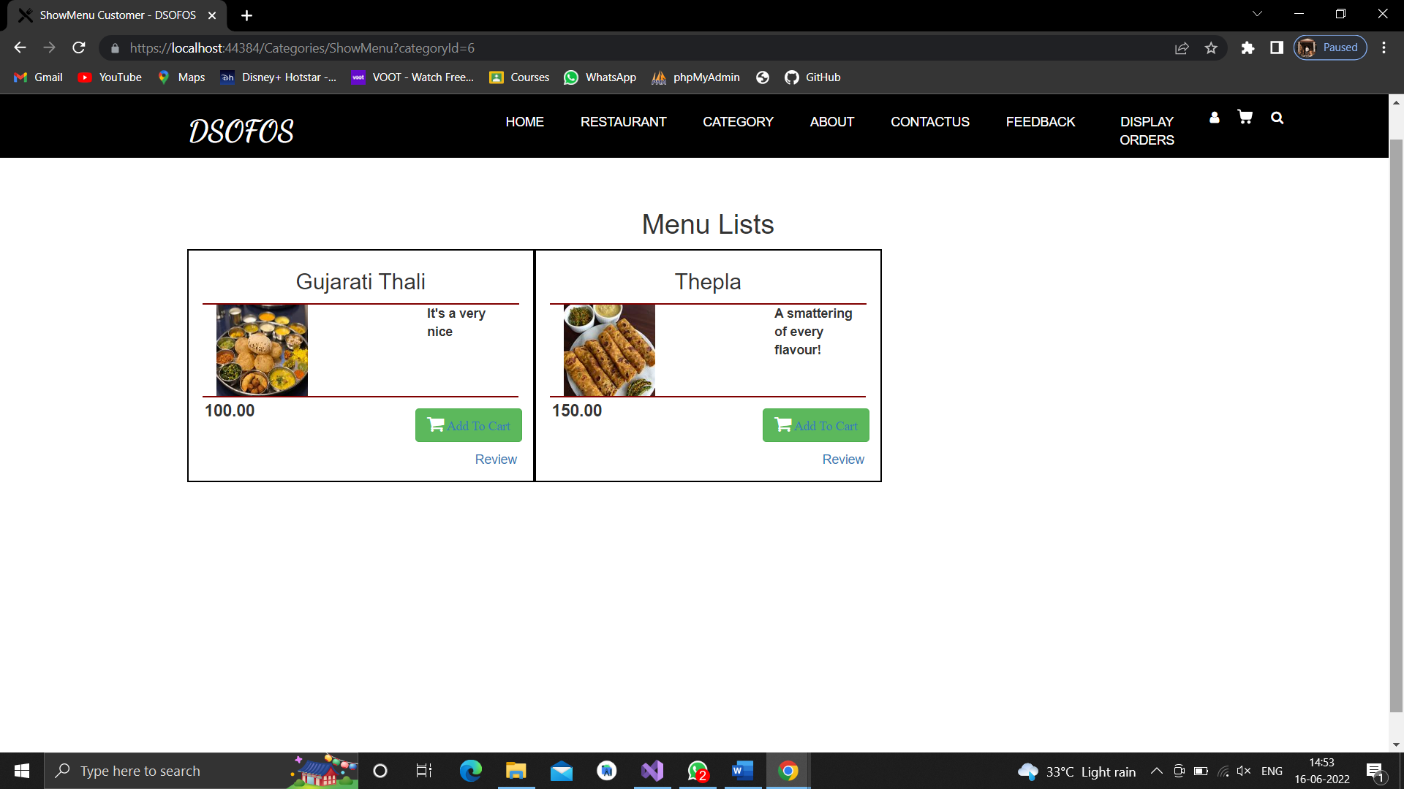

**AddtoCart**

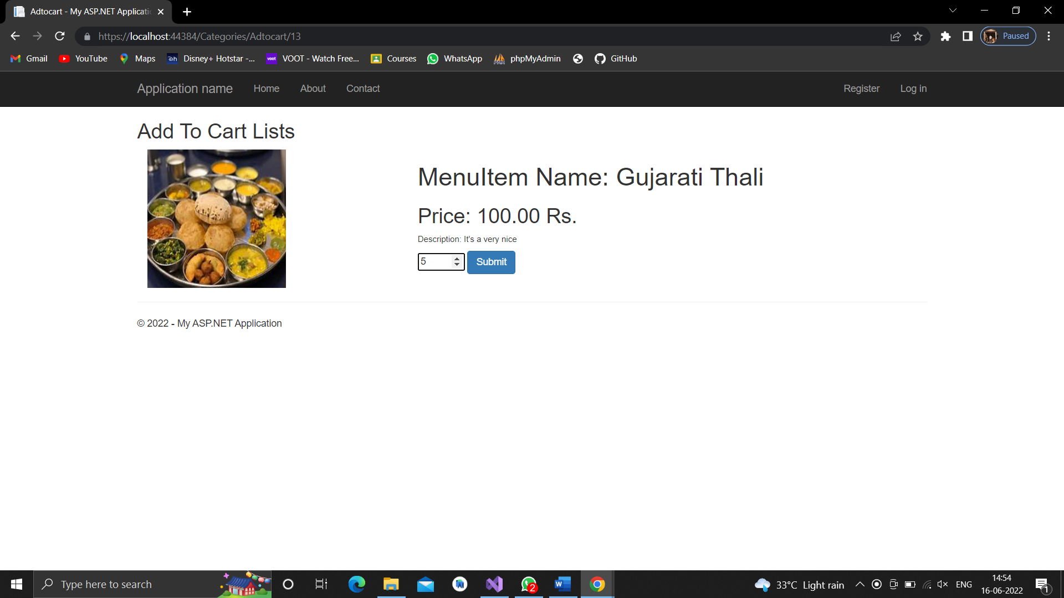

**CheckOut**

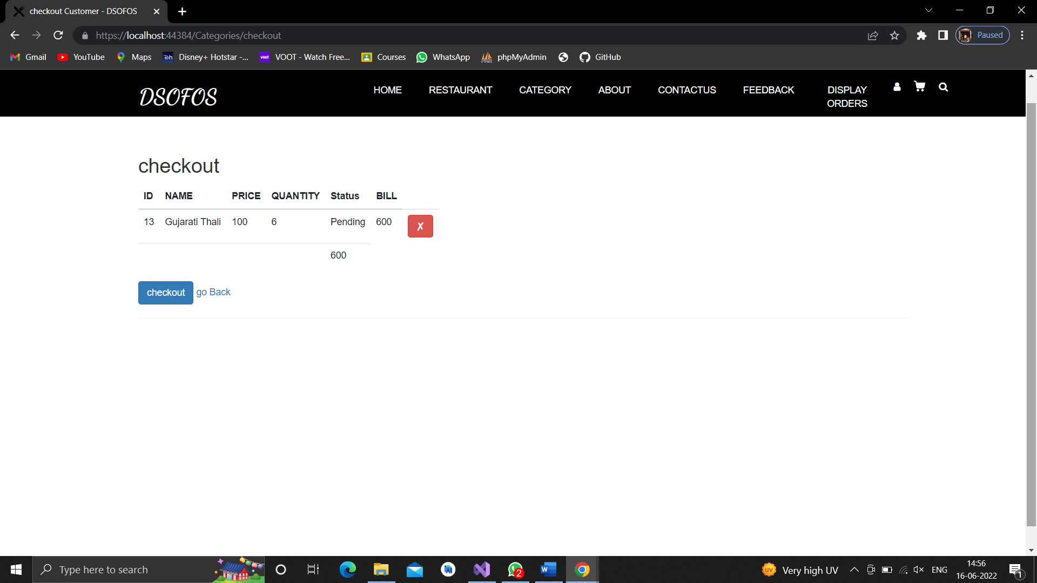

**Payment**

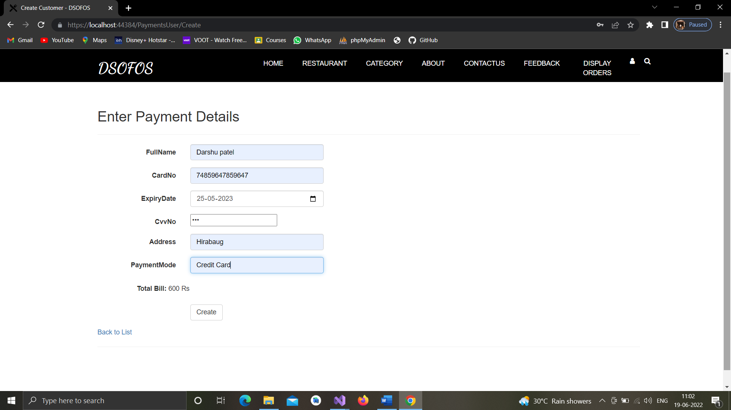

**Generate Invoice**

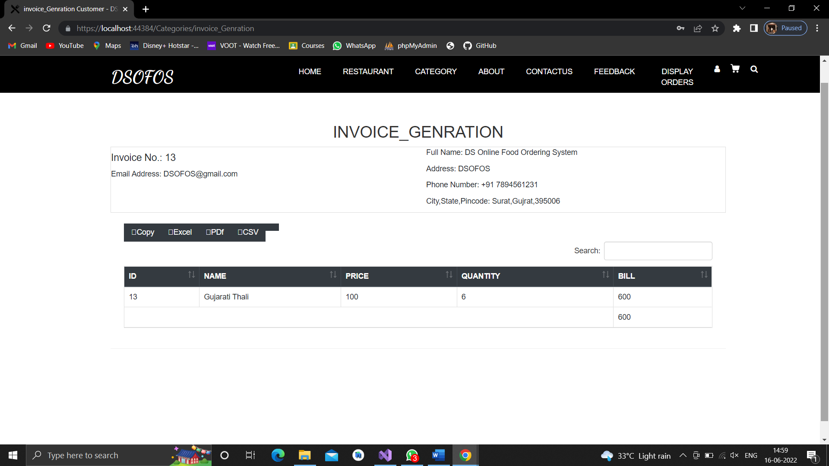

**Review**

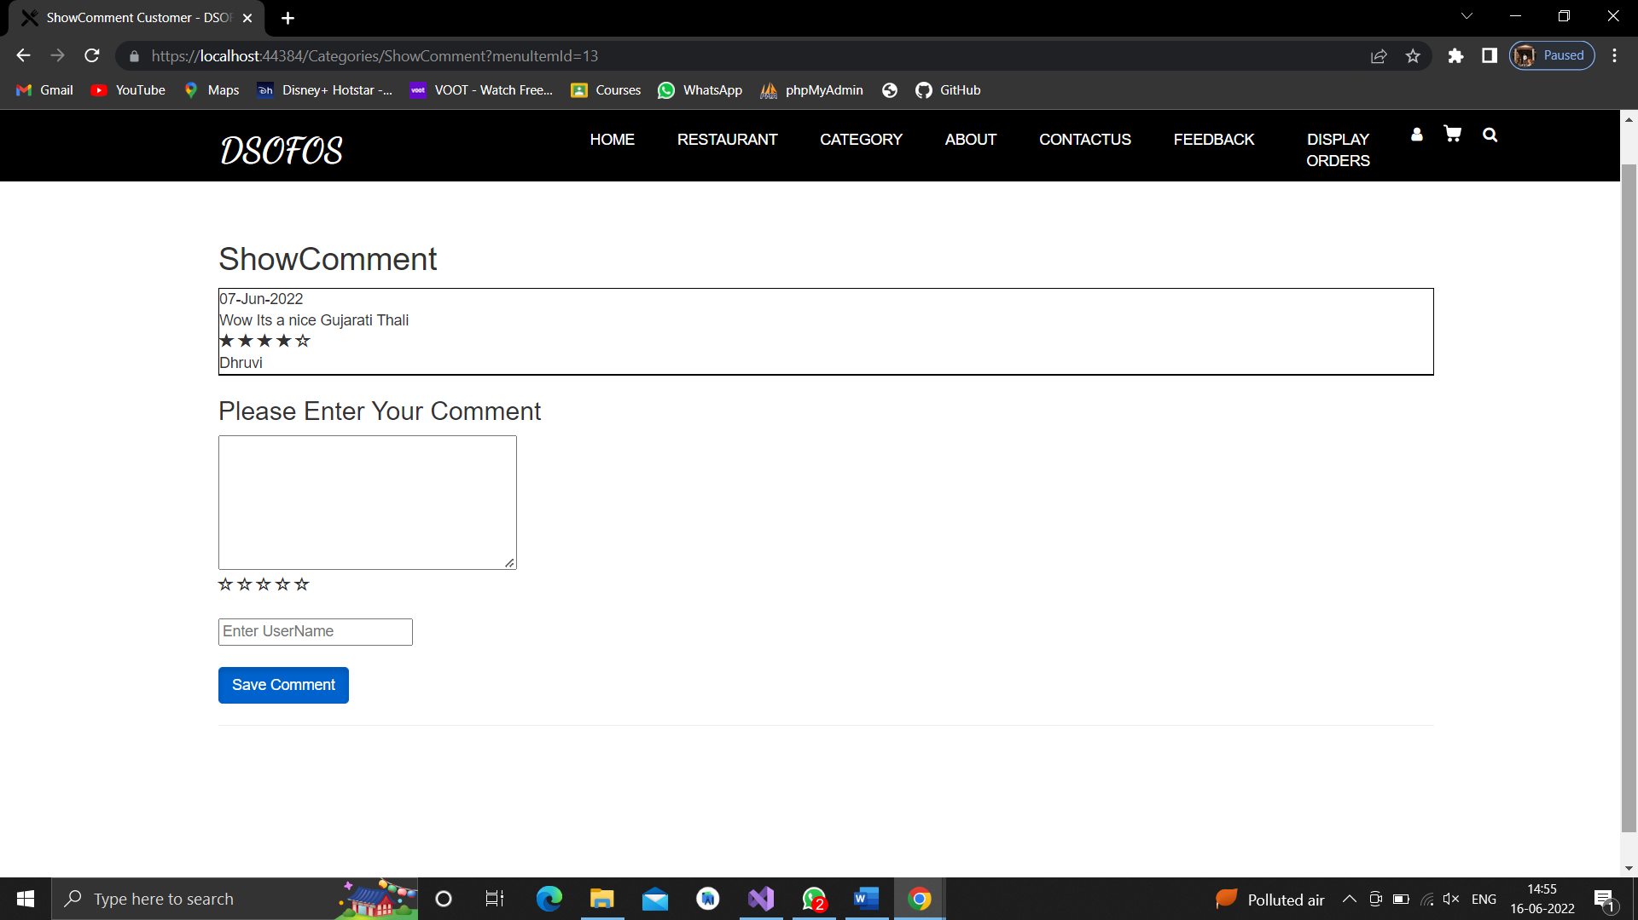

**Feedback**

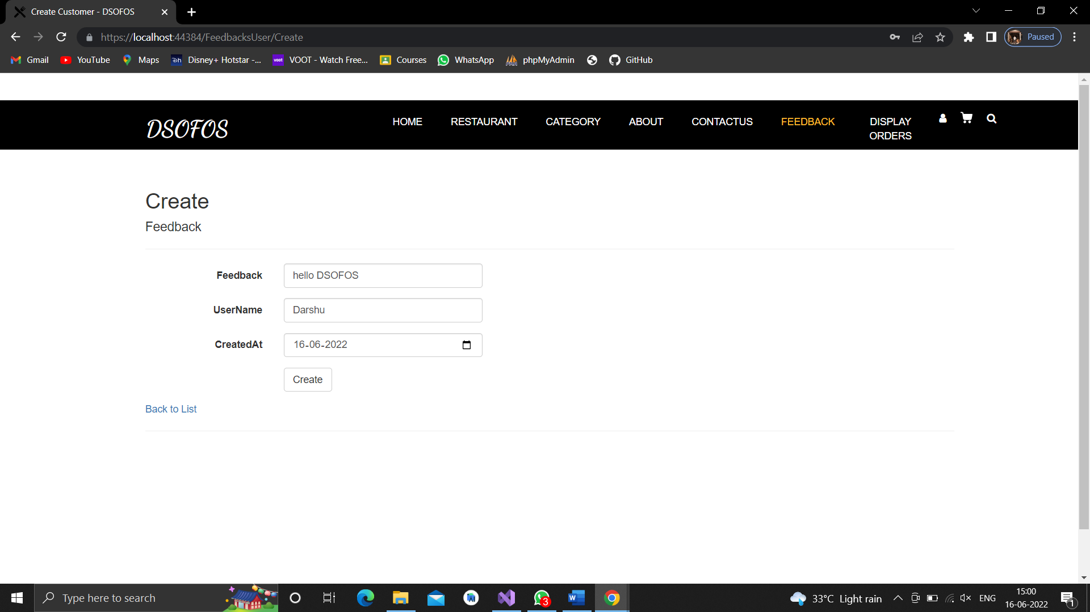

**Display Orders**

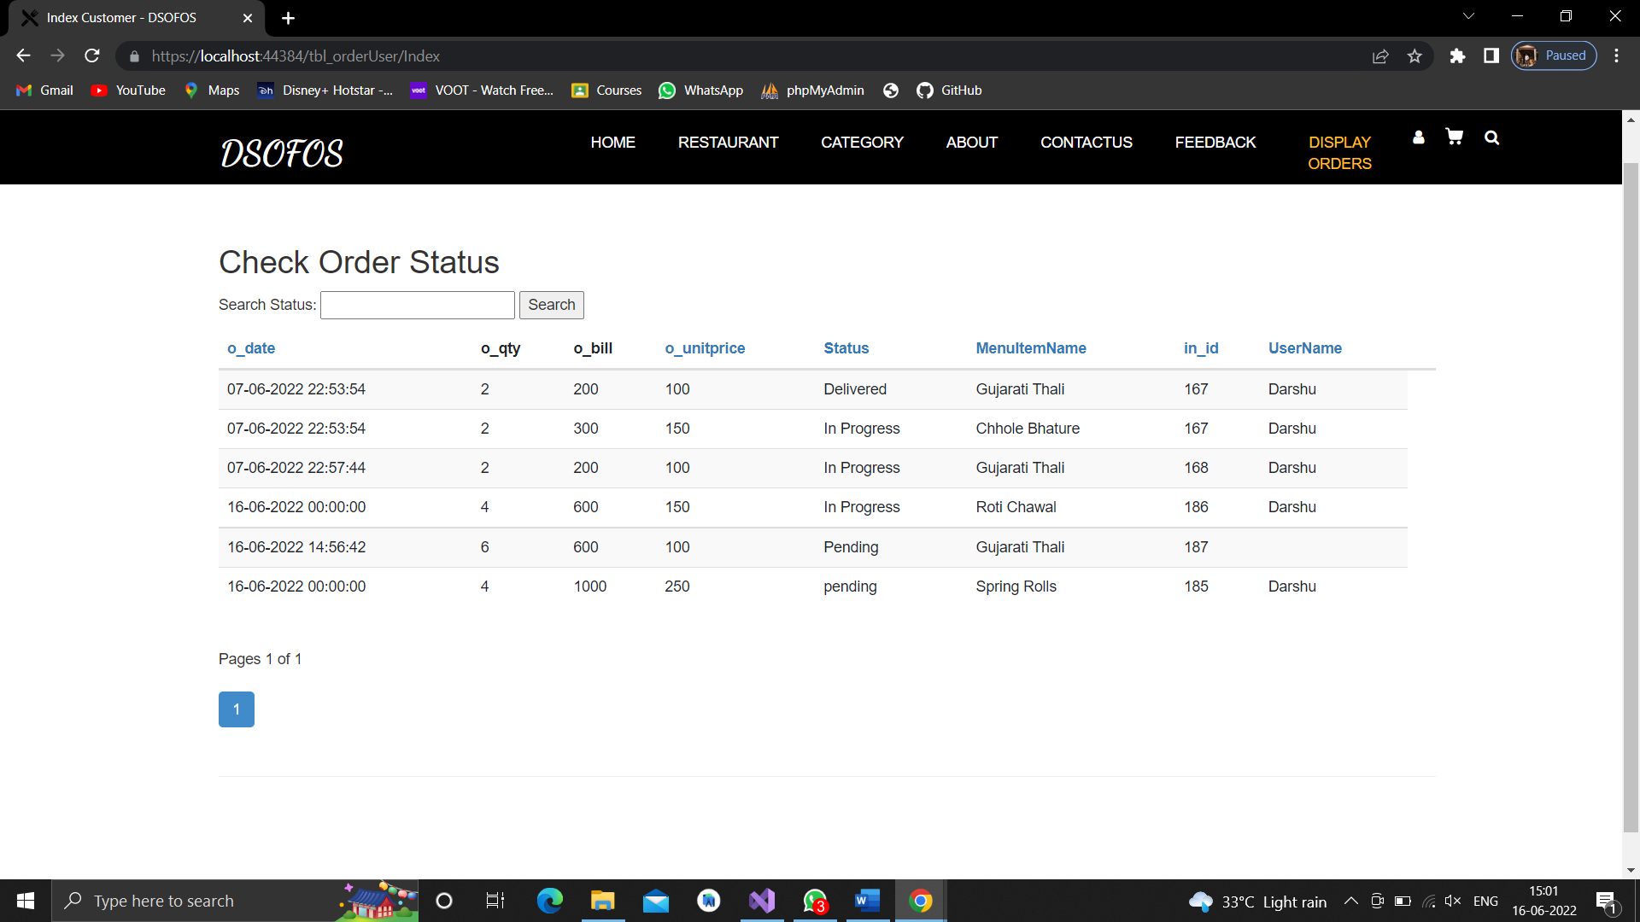

**Customer Profile**

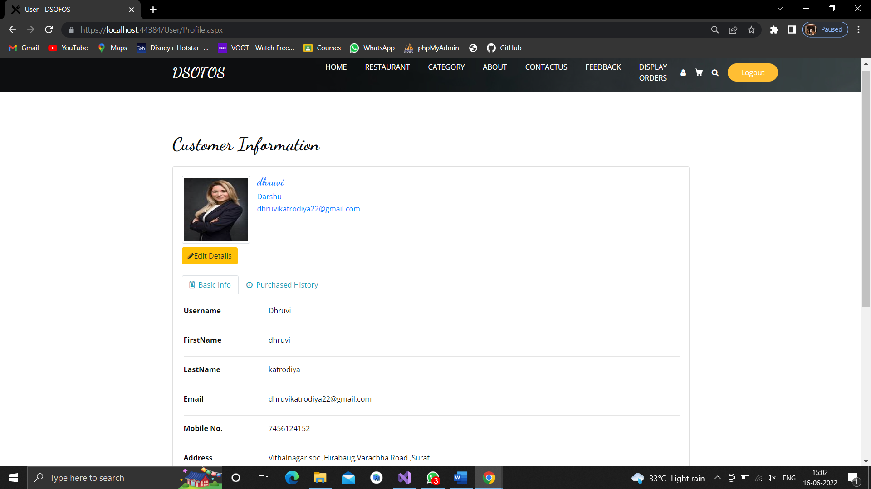

**Admin Side**

**Admin Login**

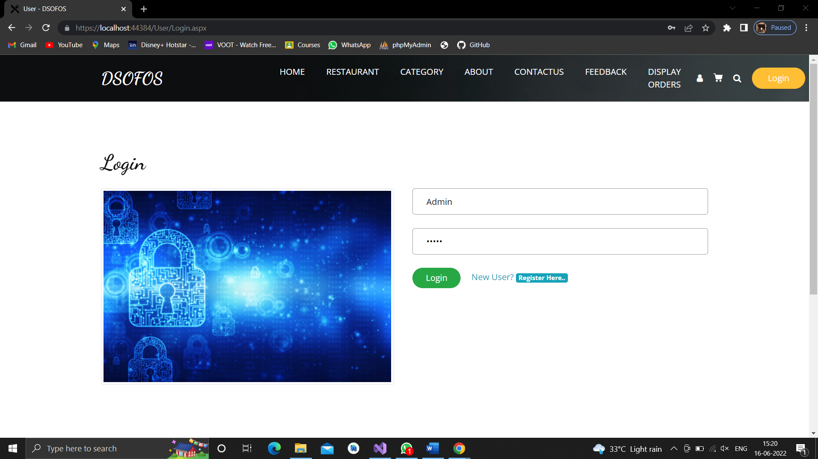

**Dashboard**

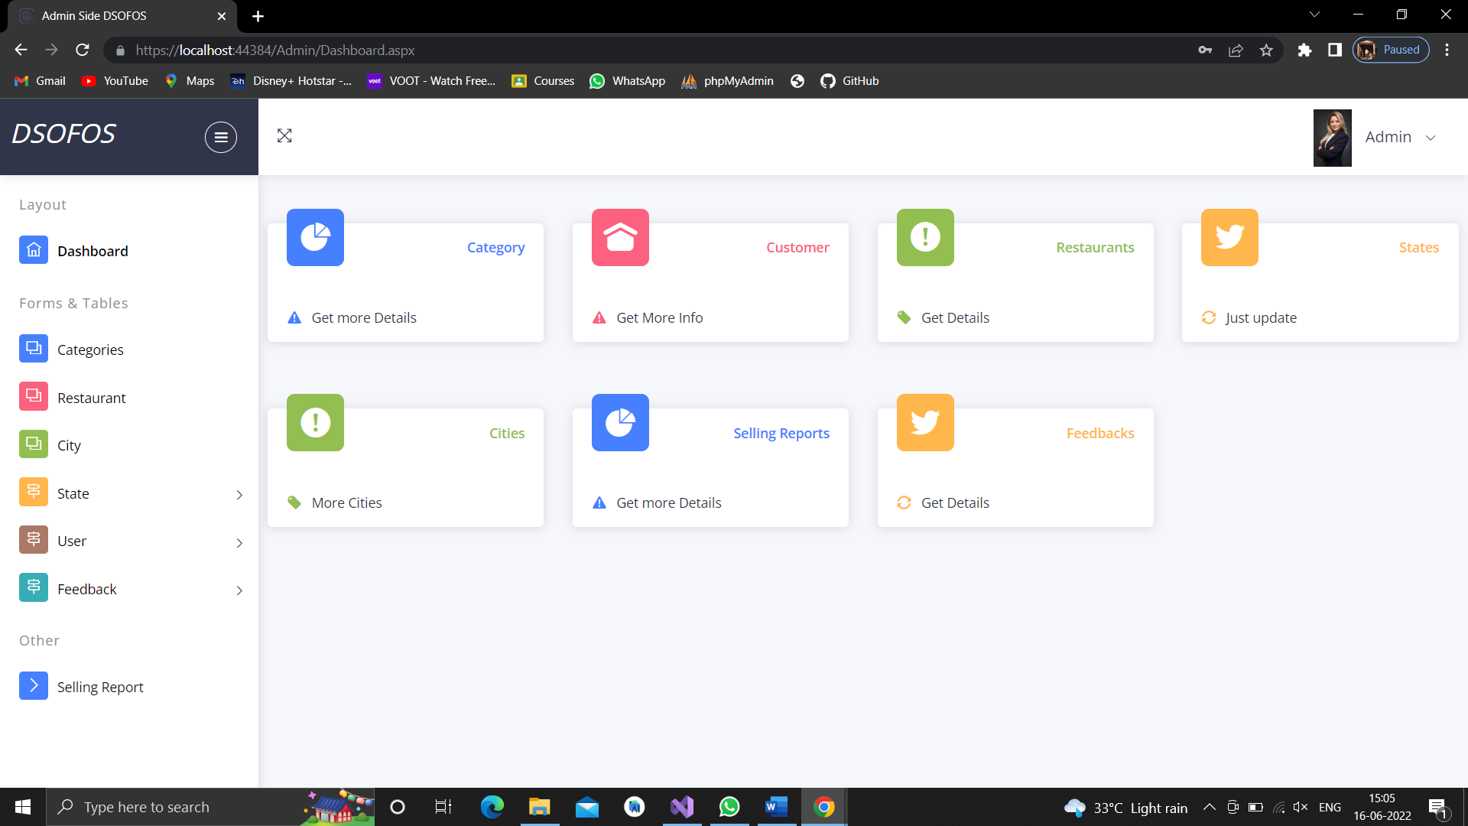

**Add Category**

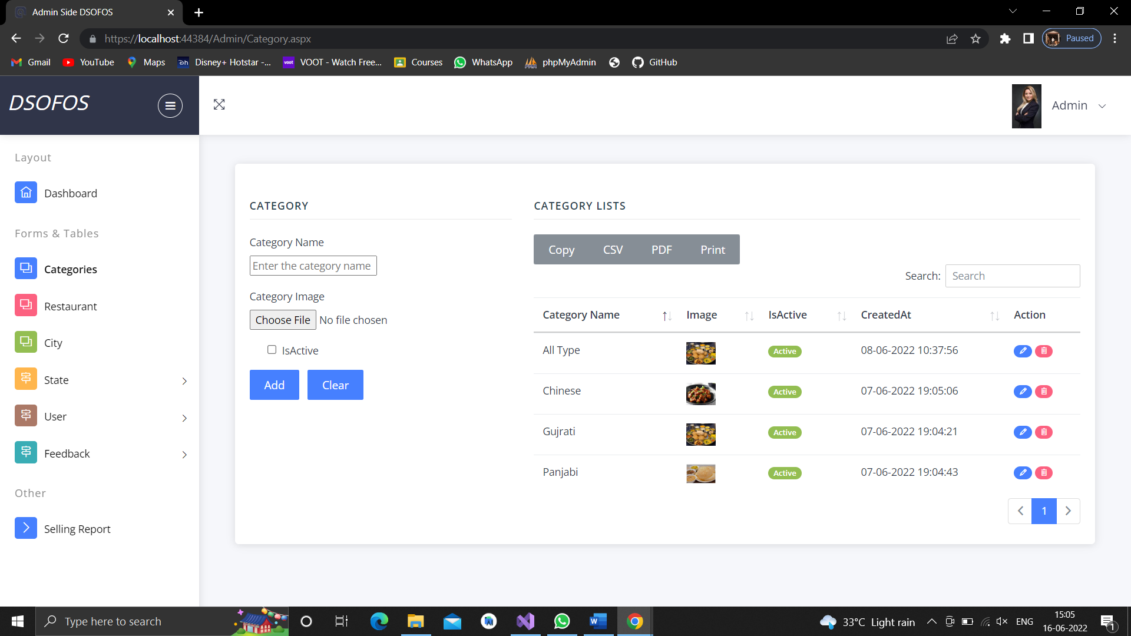

**Manage Restaurants**

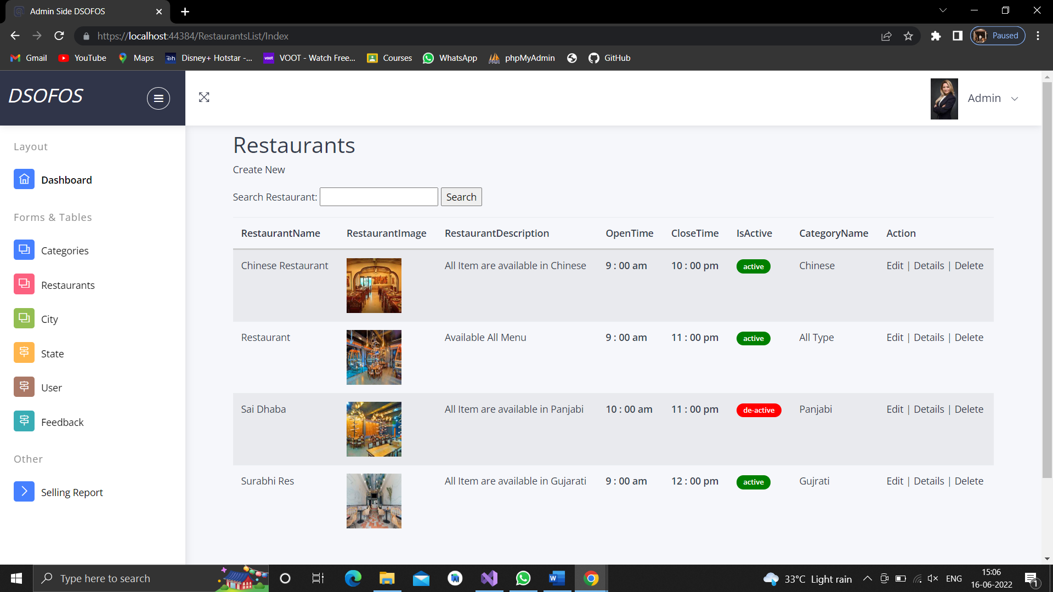

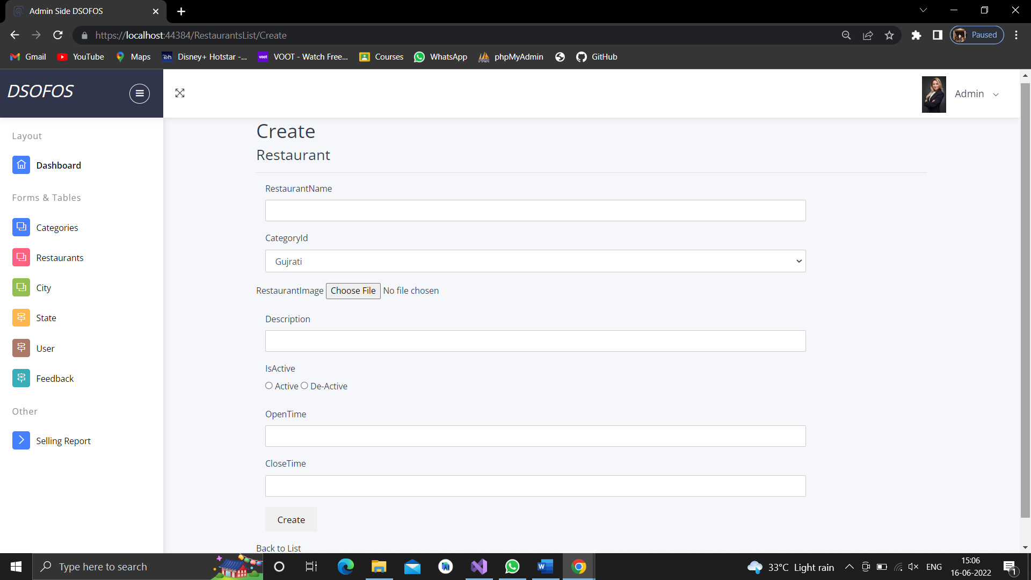

**Manage City**

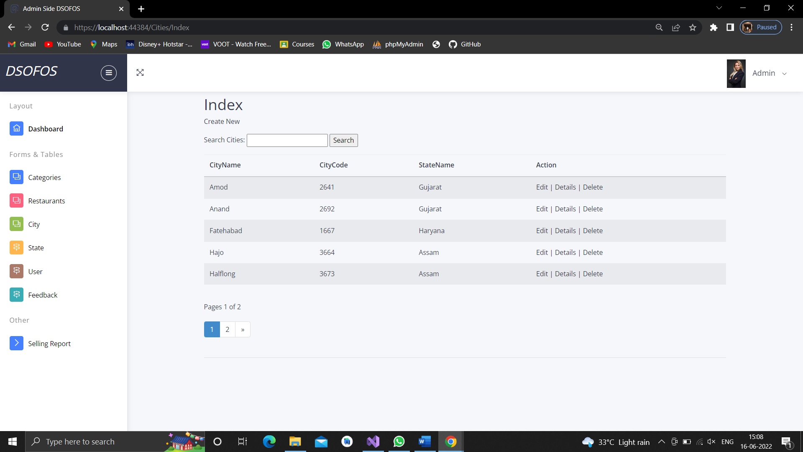

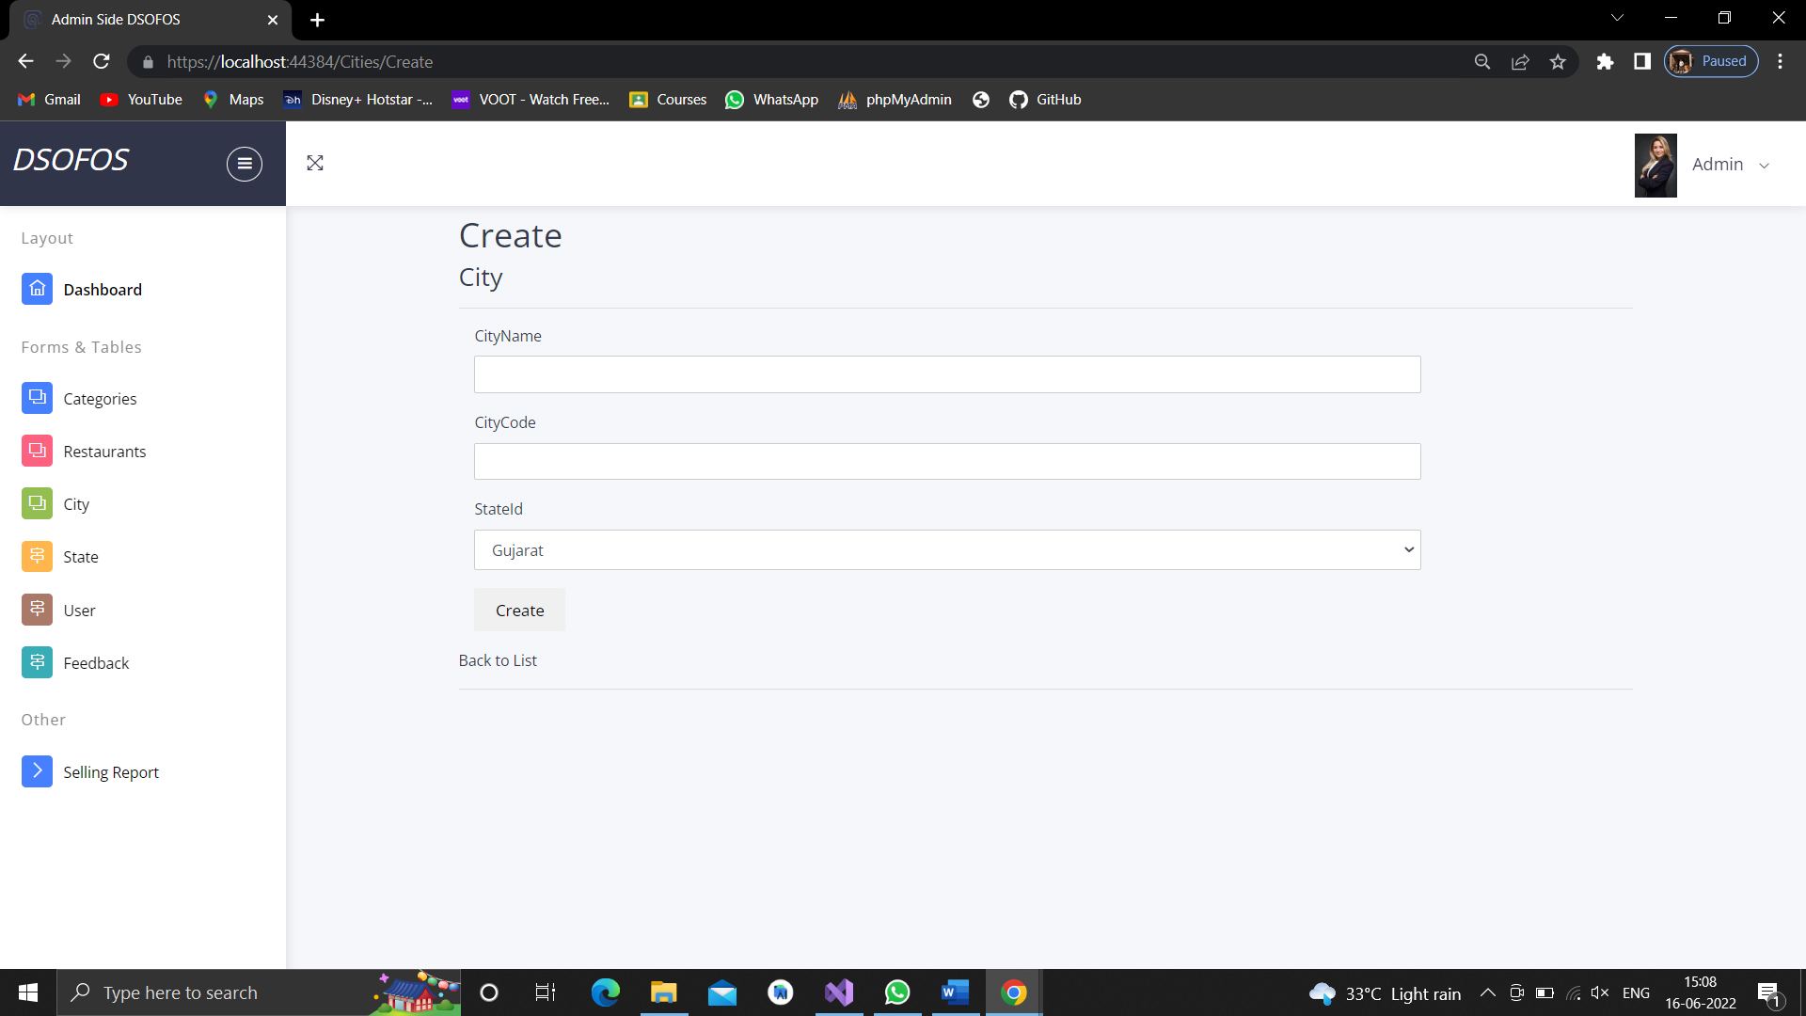

**Manage State**

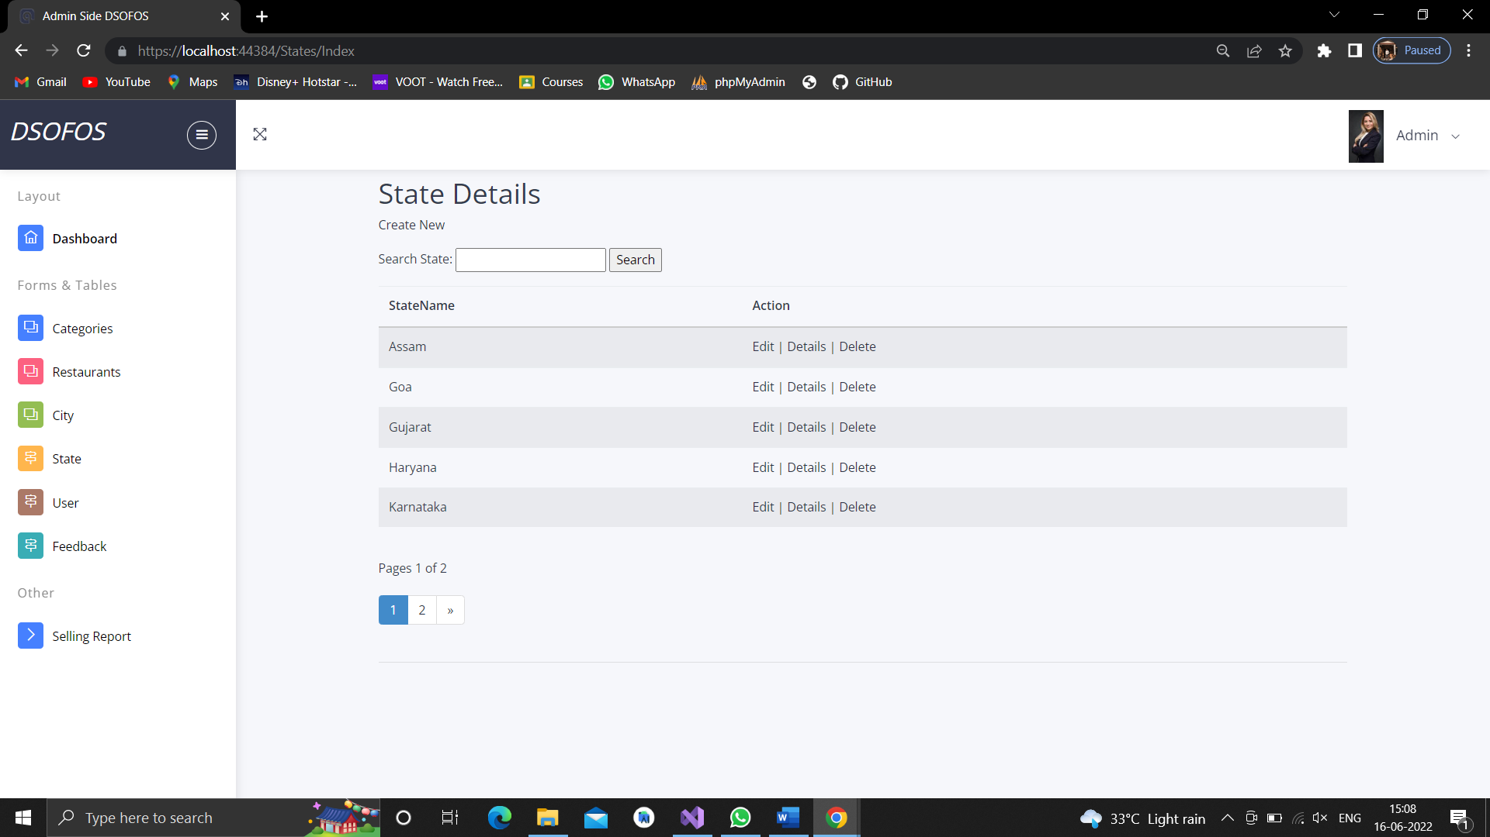

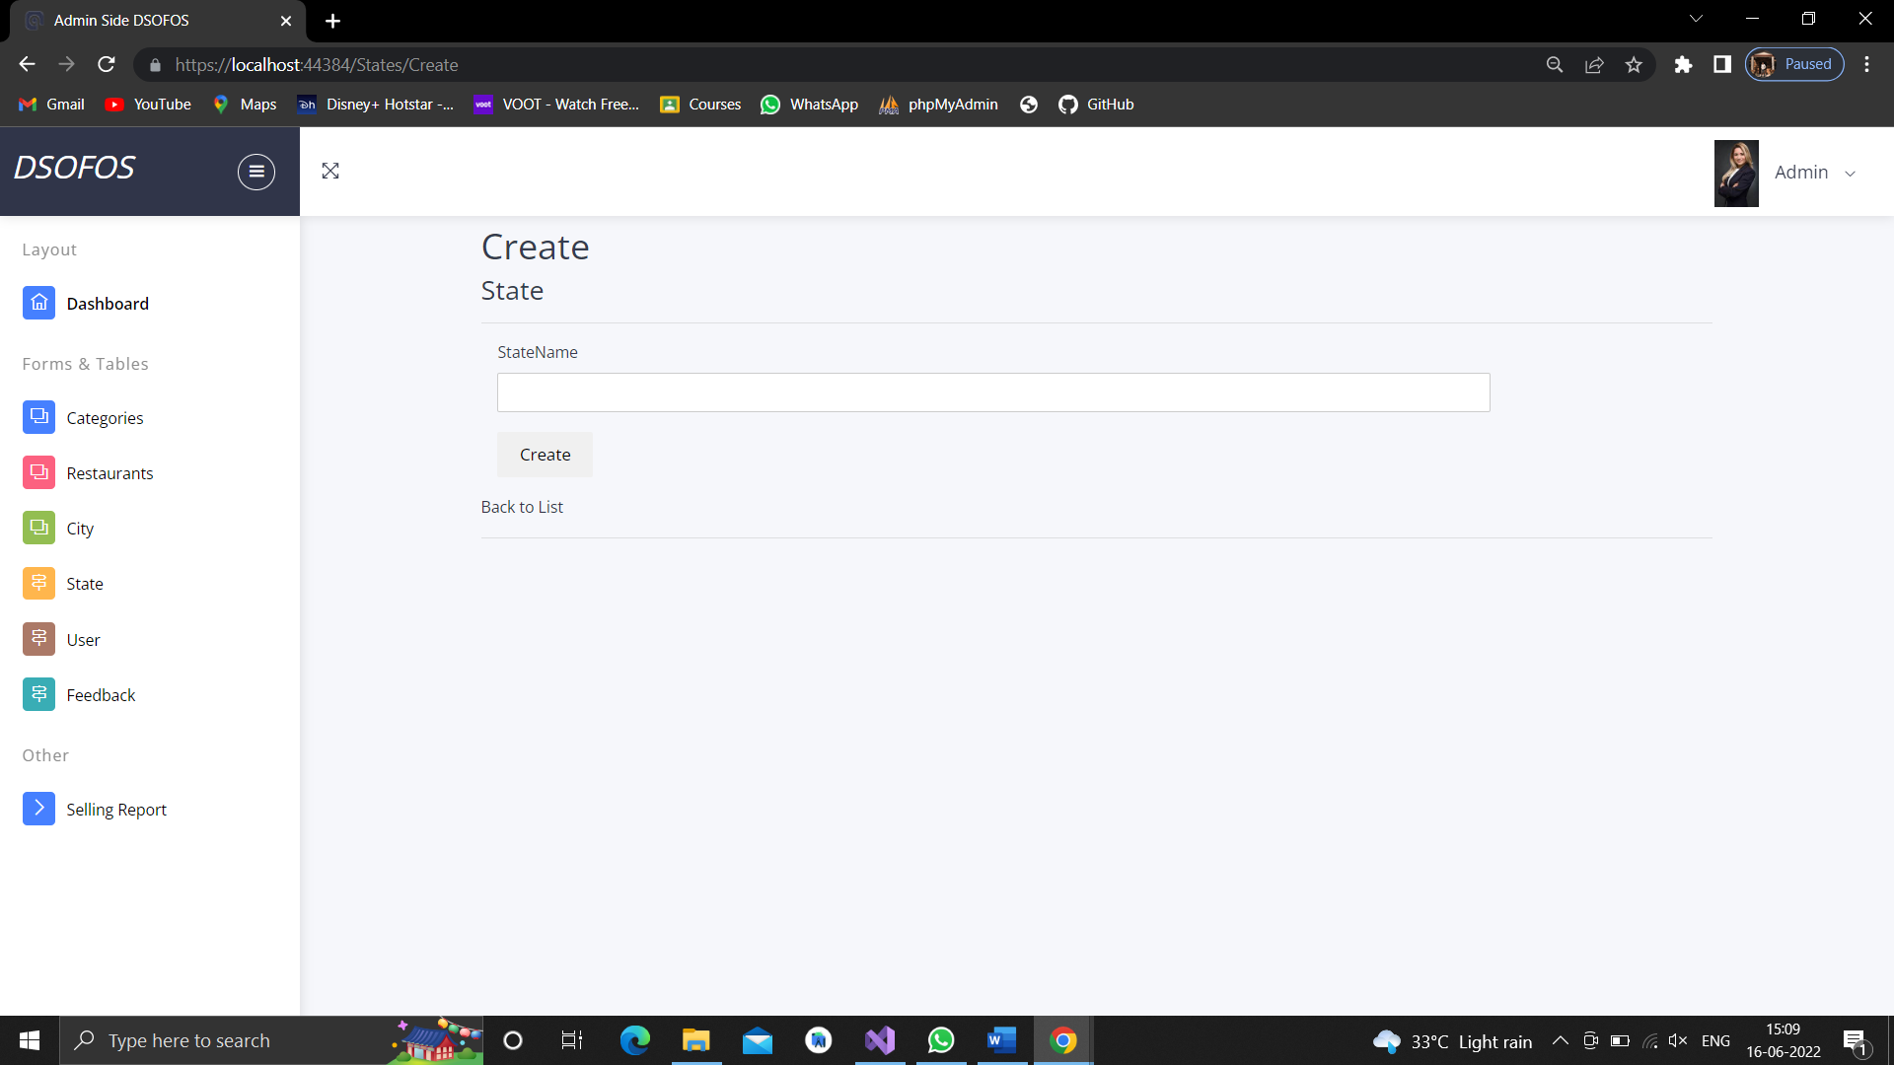

**Manage User**

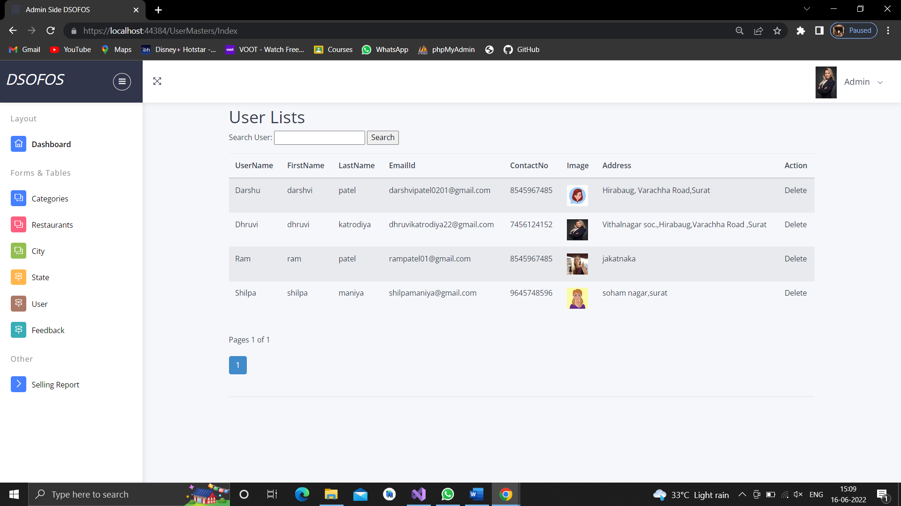

**Manage Feedback**

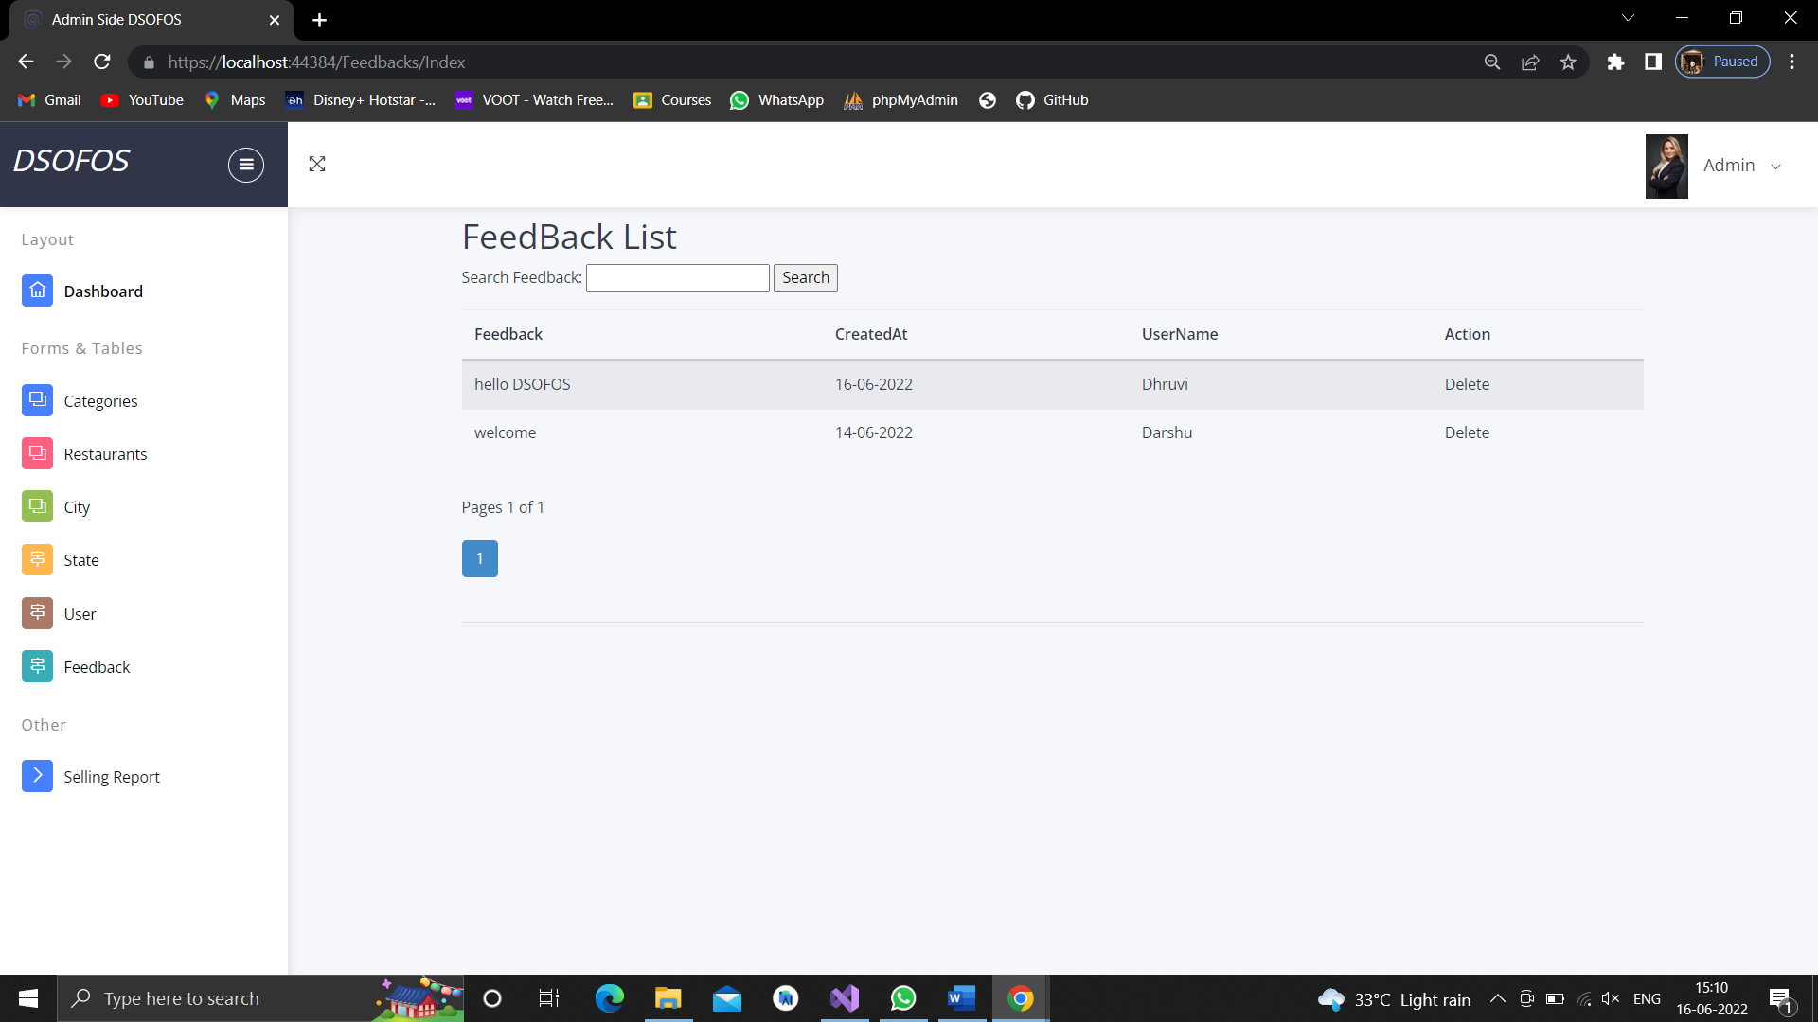

**Manage Selling Report**

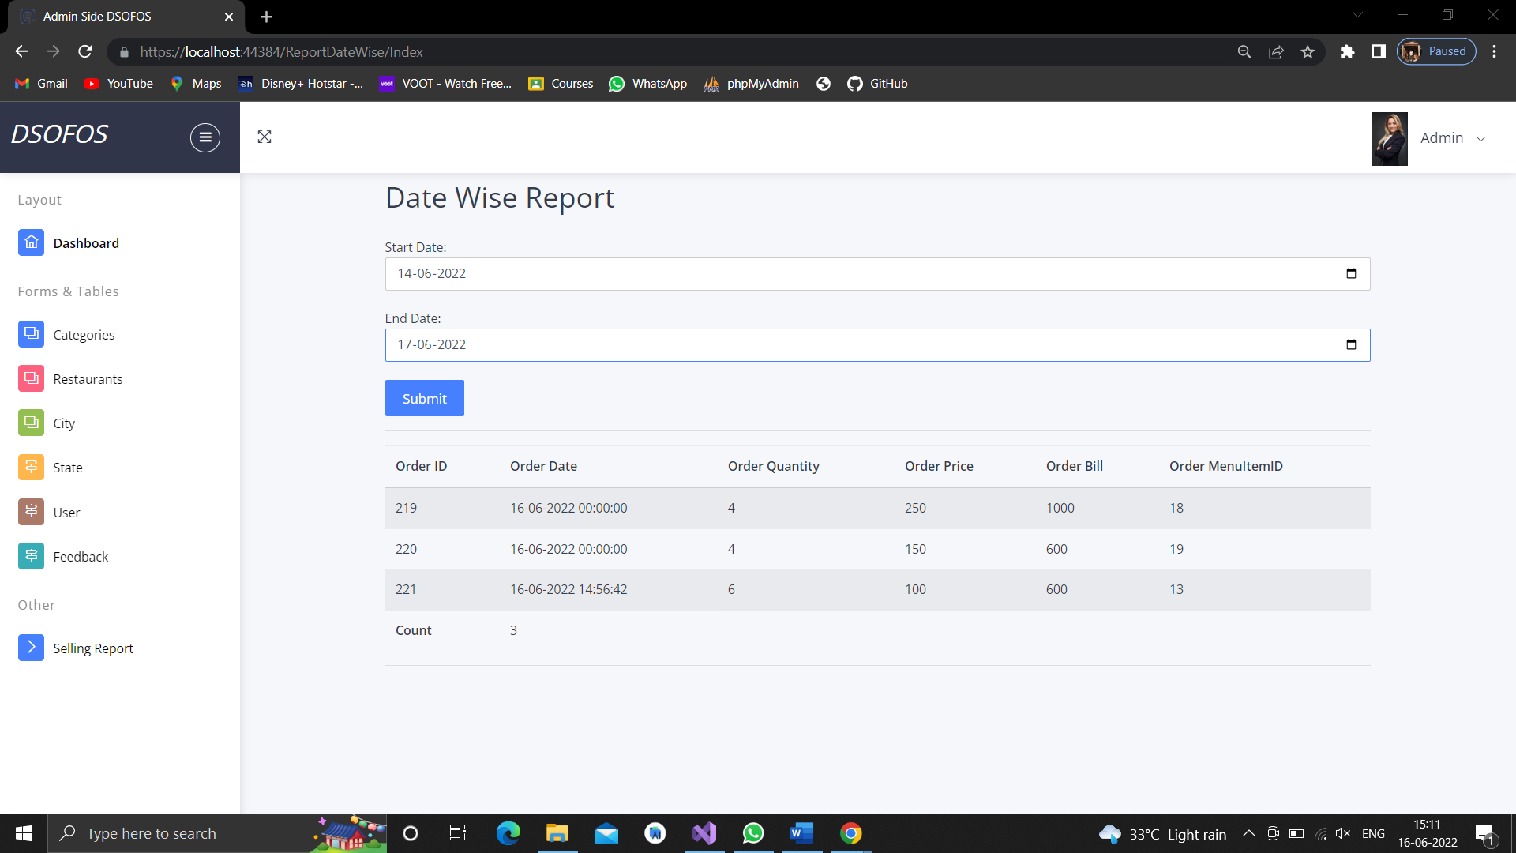

**Admin Logout**

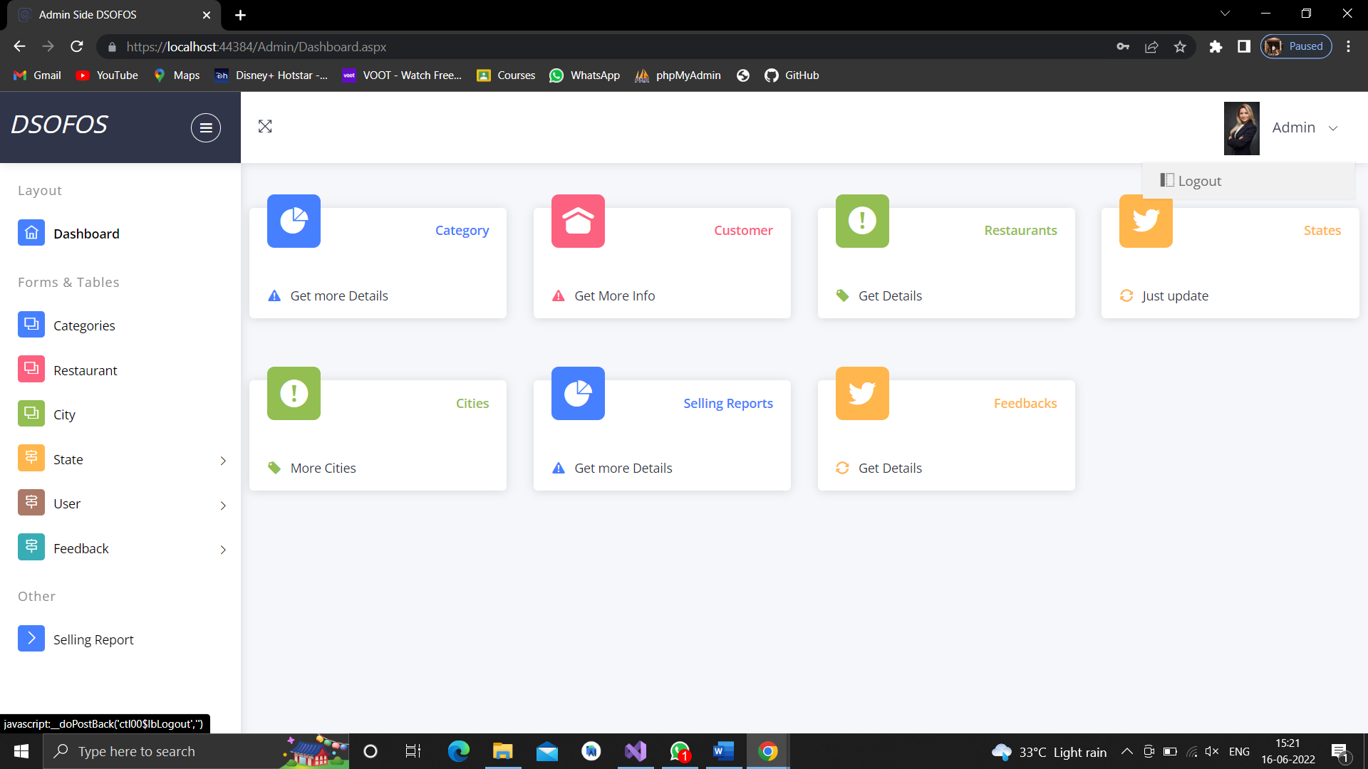

**Restaurant Side**

**Restaurant Login**

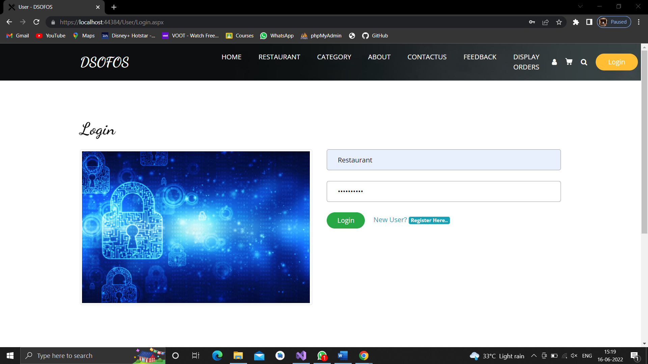

**Dashboard**

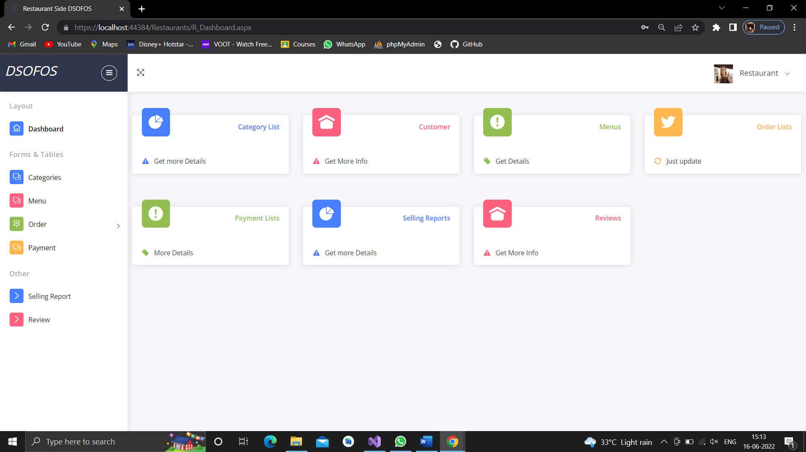

**View Category**

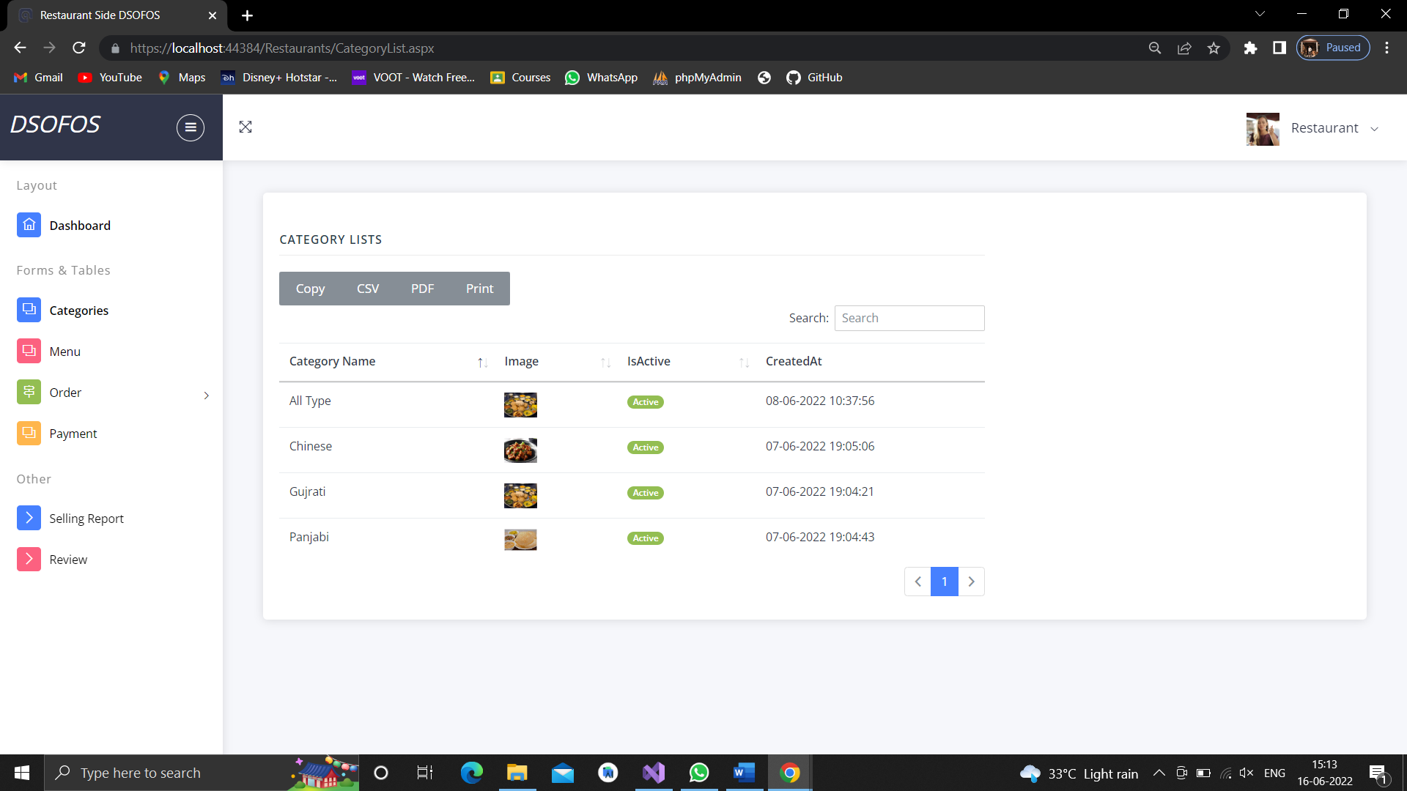

**Manage Menu**

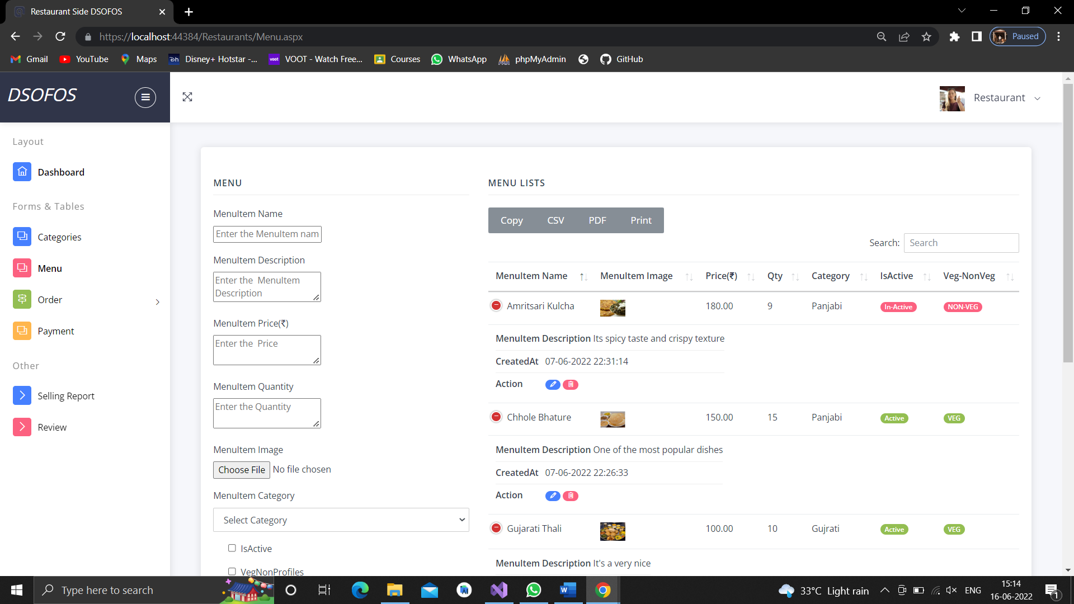

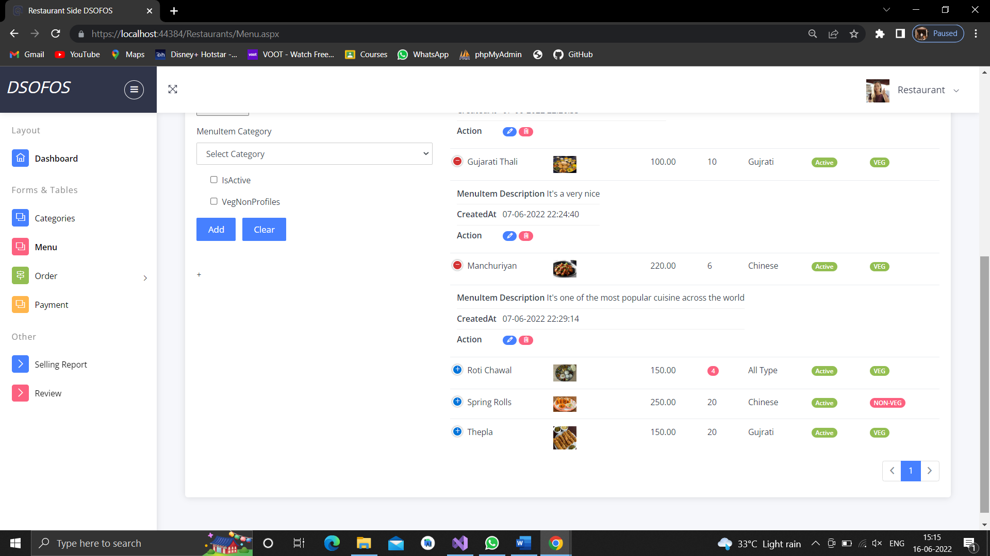

**Manage Order**

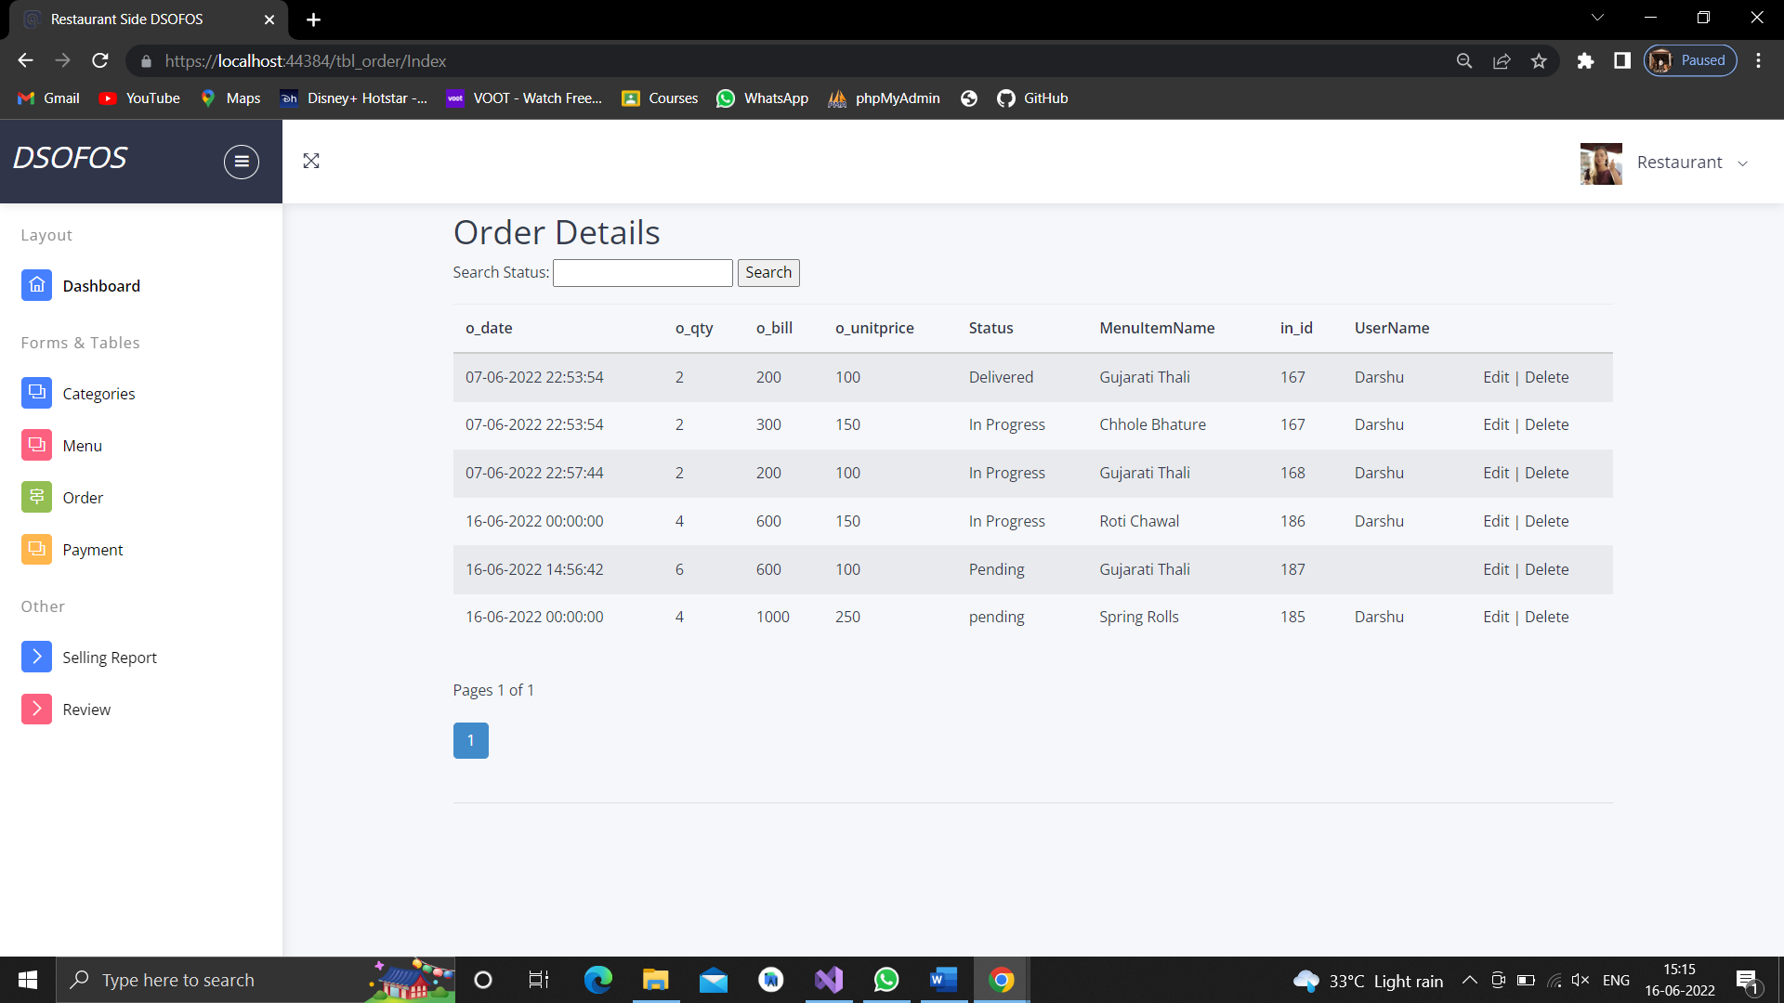

**Update Order Status**

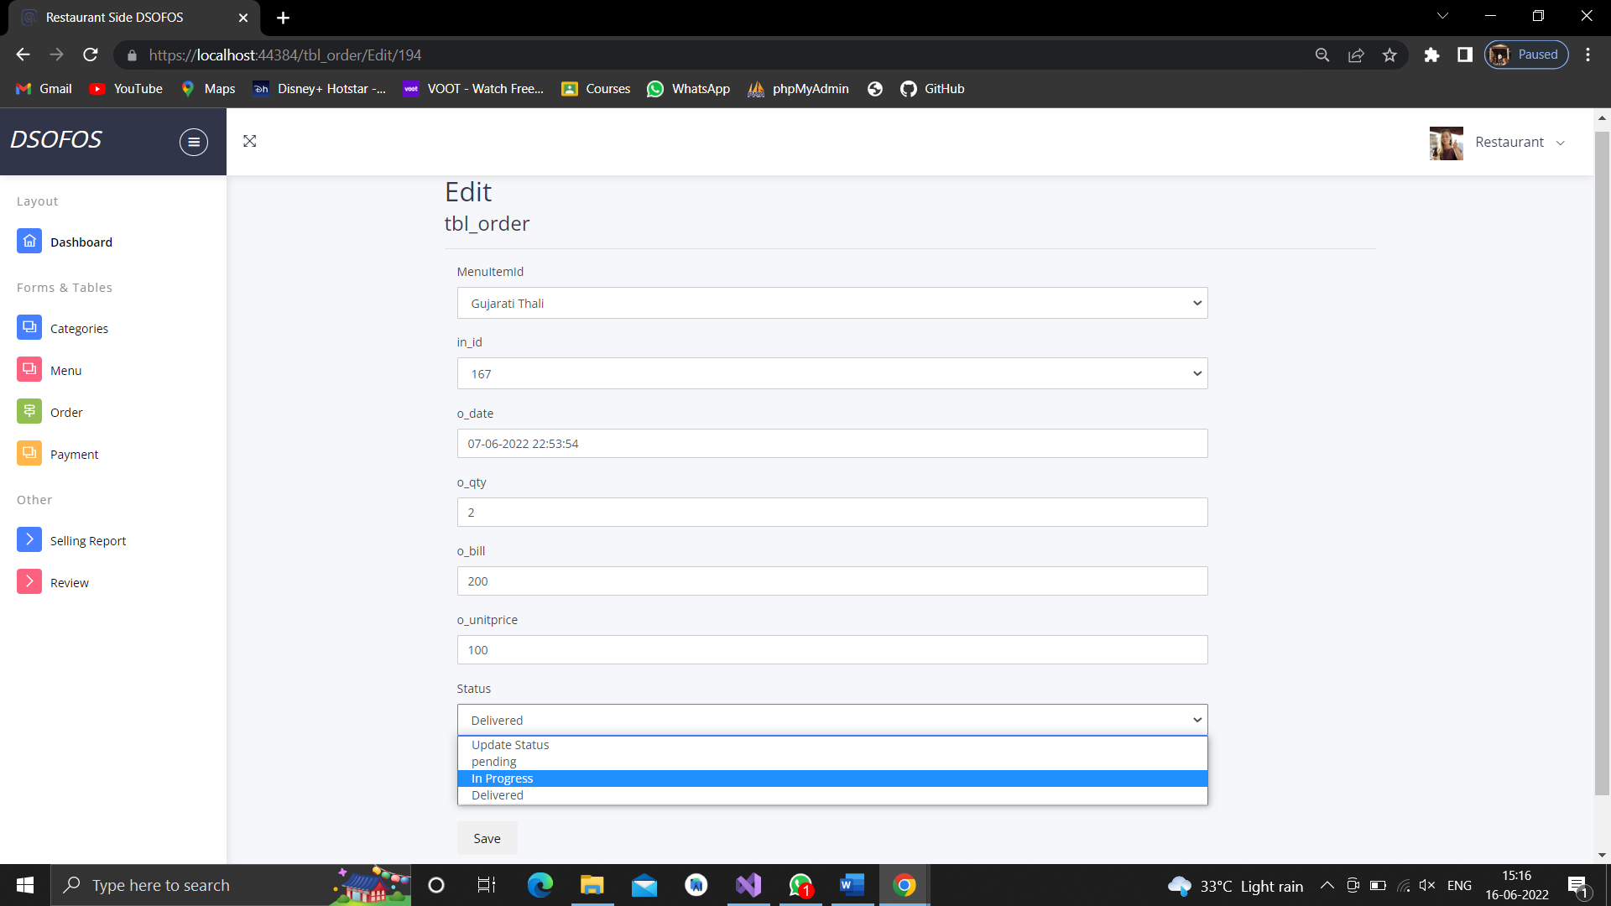

**Manage Payment**

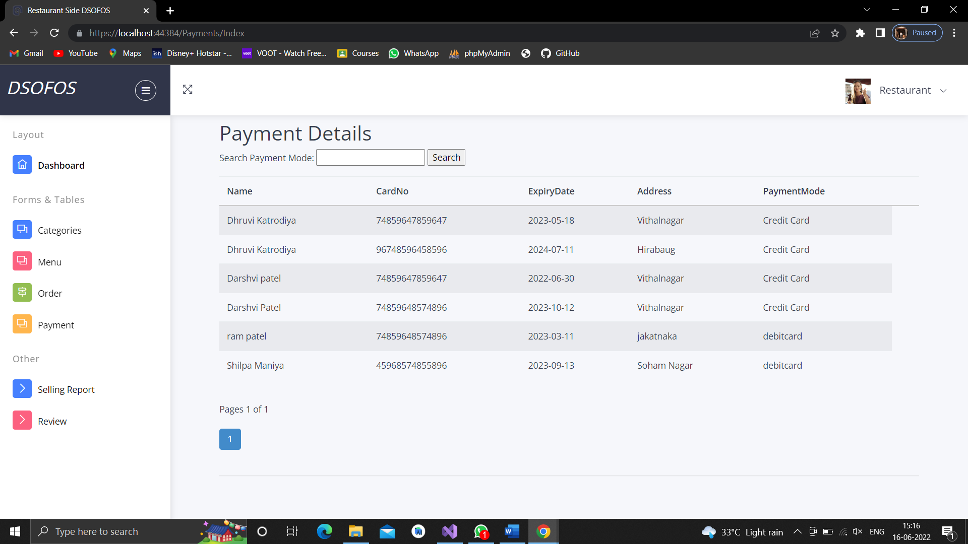

**Manage Selling Report**

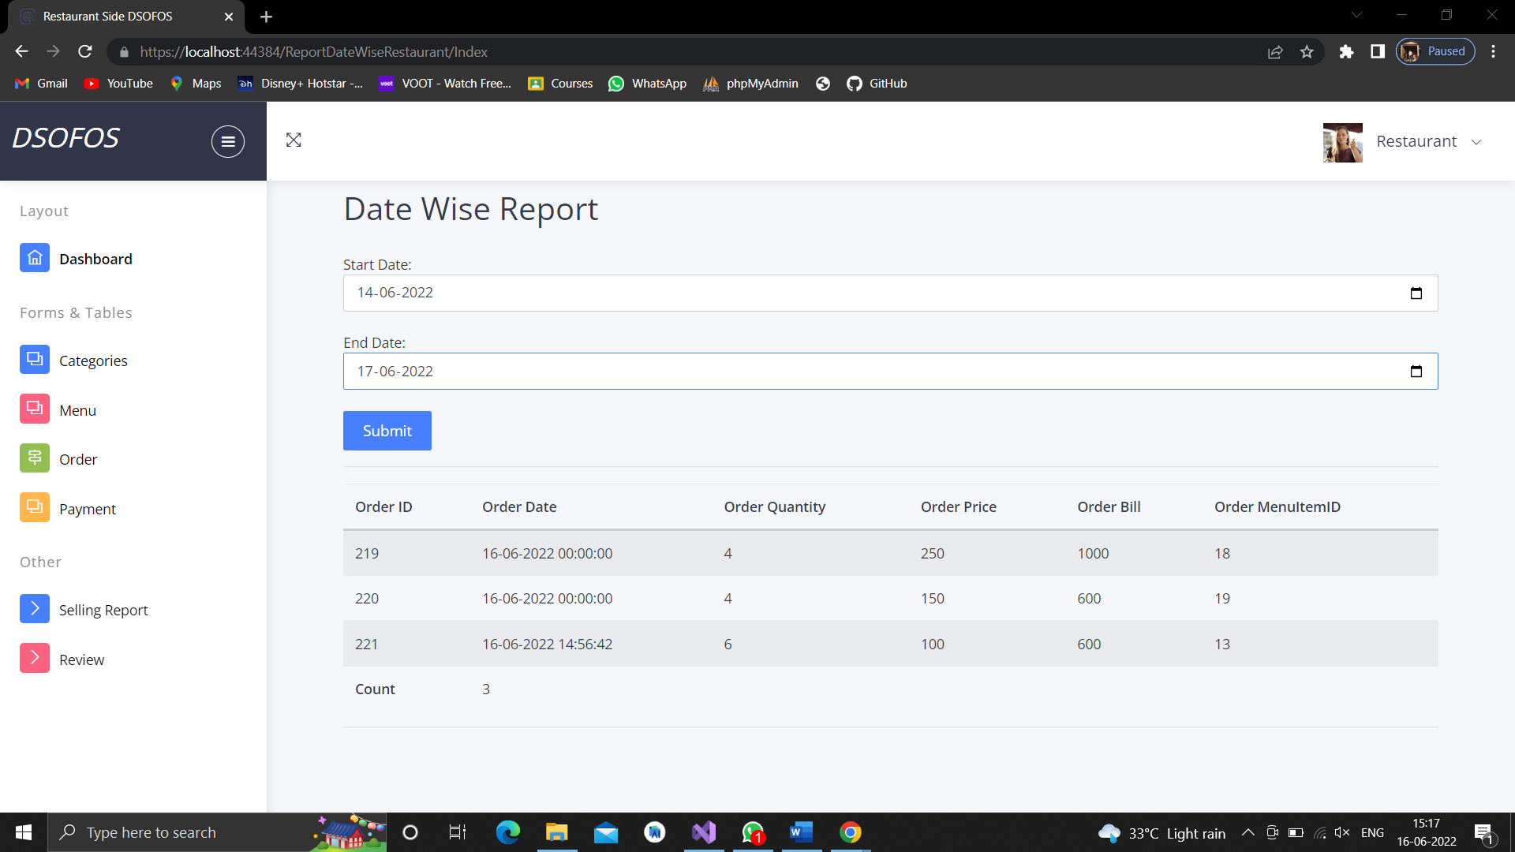

**View Review**

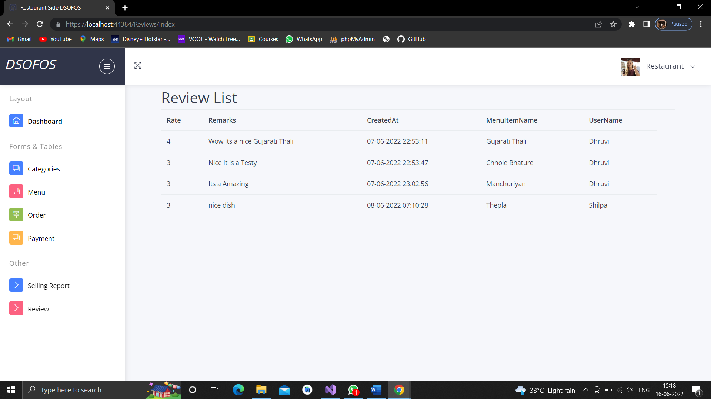

**Logout**

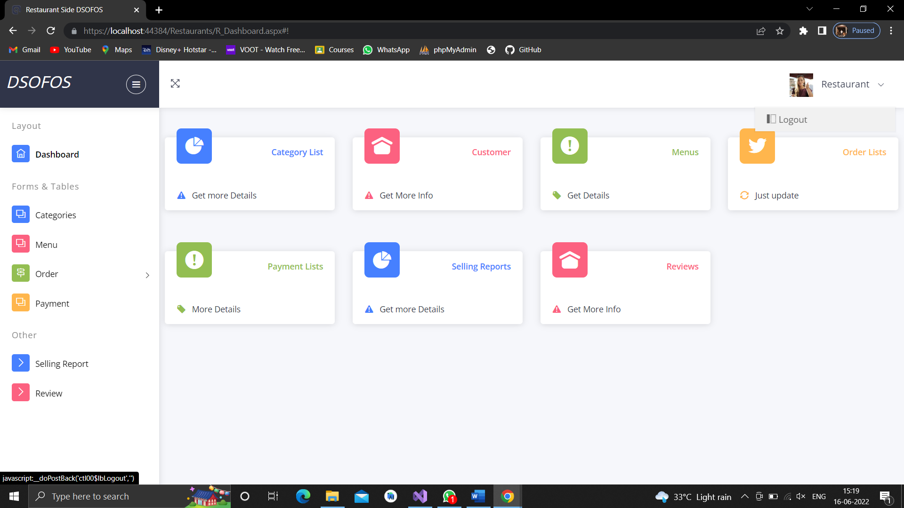

**6.3 Architecture Design(If you are using 3 tier application then you can explain it in this)**

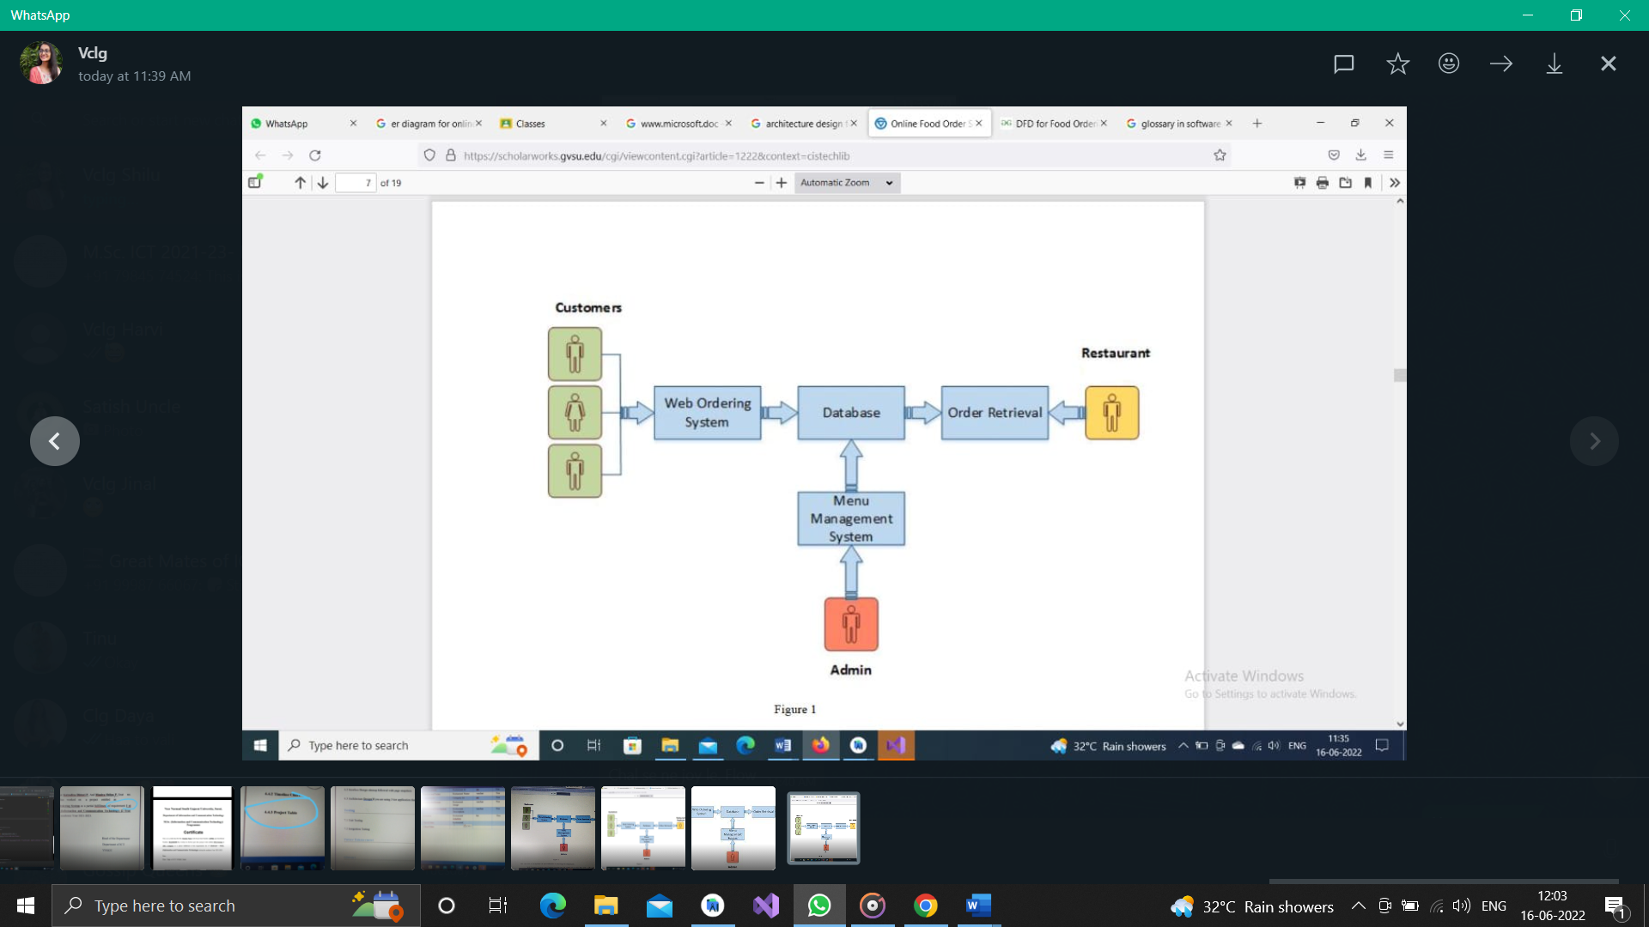

**7. Testing**

**7.1 Unit Testing**

* + A unit is an instance of a VideoMod, which contains a location, a size, and the string where the video lives.
  + Video placement can be tested by specifying the x and y locations statically (white box) or variably (black box).
  + Video pause is a simple boolean toggle statement which can be triggered statically (white box) or based on certain criteria (black box).
  + Video pixilation and swirling was tested with static values indicating cell size and how to rotate, as well as variable criterion.
  + Similarly, video speed was tested by static values indicating the play back speed as well as variables.
    - And finally, video tint is tested similarly. After it was confirmed that the functions could perform as they should, input from the sensor was used.

## Why Unit Testing?

* **Unit Testing** is important because software developers sometimes try saving time doing minimal unit testing and this is myth because inappropriate unit testing leads to high cost[Defect](https://www.guru99.com/defect-management-process.html)fixing during [System Testing](https://www.guru99.com/system-testing.html), [Integration Testing](https://www.guru99.com/integration-testing.html) and even Beta Testing after application is built.
  + - If proper unit testing is done in early development, then it saves time and money in the end.

1. Unit tests help to fix bugs early in the development cycle and save costs.
2. It helps the developers to understand the testing code base and enables them to make changes quickly.
3. Good unit tests serve as project documentation.
4. Unit tests help with code re-use. Migrate both your code **and** your tests to your new project. Tweak the code until the tests run again.**Unit Testing Advantage**

* Developers looking to learn what functionality is provided by a unit and how to use it can look at the unit tests to gain a basic understanding of the unit API.
* Unit testing allows the programmer to refactor code at a later date, and make sure the module still works correctly (i.e. Regression testing). The procedure is to write test cases for all functions and methods so that whenever a change causes a fault, it can be quickly identified and fixed.
* Due to the modular nature of the unit testing, we can test parts of the project without waiting for others to be completed.

## Unit Testing Disadvantages

* Unit testing can’t be expected to catch every error in a program. It is not possible to evaluate all execution paths even in the most trivial programs
* Unit testing by its very nature focuses on a unit of code. Hence it can’t catch integration errors or broad system level errors.

**7.2 Integration Testing**

* Once the video manipulation functions were tested for efficiency, the projects were created, each with its own main class.
* The setup() and draw() functions were crafted to perform what each project hoped to achieve, integrating the sensors, video cameras, and green screens.
* Each project is tested separately by manually observing if the project is behaving as it is expected.

## Why do Integration Testing?

* **Test Cases for Login**

|  |  |
| --- | --- |
| Test Case | 1 |
| Description | Login |
| Pre-condition | Admin and User know username and Password.  Both Field should not be empty. |
| Test Action | Allow access or deny access. |
| Error Message | Invalid Username or Password. |

* **Test Cases for Registration**

|  |  |
| --- | --- |
| Test Case | 2 |
| Description | Registration |
| Pre-condition | Field should not be empty and should be of database data type. |
| Test Action | Create new user. |
| Error Message | Enter Valid Data. |

* **Test Cases for Add Admin Side**

|  |  |
| --- | --- |
| Test Case | 3 |
| Description | Add/View/Update/Delete Data |
| Pre-condition | Field should not be empty. |
| Test Action | Data will be added/updated/deleted |
| Error Message | Invalid field Values.. |

* **Test Cases for Add Restaurant Side**

|  |  |
| --- | --- |
| Test Case | 3 |
| Description | Add/View/Update/Delete Data |
| Pre-condition | Field should not be empty. |
| Test Action | Data will be added/updated/deleted |
| Error Message | Invalid field Values.. |

**Advantages:**

* Fault localization is easier.
* No time  is wasted waiting for all modules to be developed unlike Big-bang approach

**Disadvantages:**

* Critical modules (at the top level of software architecture) which control the flow of application are tested last and may be prone to defects.
* An early prototype is not possible

**8. Future Enhancement**

* We can make our system platform independent which means that it can be work on any operating system.
* The website can be implemented on the internet in future.
* We give more security to the user.
* In future our website provide credit card and debit card payments as well as net banking with the security.
* A E-wallet can also transaction easy and safe.
* We can make site on international level.

**9. Reference**

1. <http://stackoverflow.com>
2. <http://www.sanfoundary.com>
3. <https://www.c-sharpcorner.com>
4. <http://w3school.com>
5. <https://microsoft.doc>